

Table of Contents

1.0 Chapter 1: Introduction 1

1.1 System Background 1

1.2 Problem Facing 2

1.3 Aim 2

1.4 Objectives 3

1.5 Gantt Chart 4

2.0 Chapter 2: Literature Review 6

2.1 Introduction 6

2.2 Product Research - Advantage of Course Registration and Management System 7

2.2.1 Safe and easy way for a student to register course in this system 7

2.2.2 Students can register at any time in this system 7

2.2.3 Students can use waiting list function to queue for their preferred course 8

2.2.4 Lecturer can easily view the timetable and record attendance 8

2.2.5 Reduce workload 9

2.3 Research and Review of Similar Products 10

2.3.1 iTrain 10

2.3.2 The Knowledge Academy 12

2.3.3 Asia Dev Academy 14

2.3.4 Next Academy 15

2.3.5 Skill Based IT Training 16

2.4 Table of Comparison 17

2.5 Course Registration Research 18

2.5.1 Online Course Registration 18

2.5.2 Online Course Registration and Management System 19

2.6 Tool and Software Research 20

2.6.1 MySQL 20

2.6.2 PHP 20

2.6.3 HTML 21

2.6.4 JavaScript 21

2.6.5 Notepad++ 22

2.6.6 Microsoft Office 22

2.7 Conclusion 23

3.0 Chapter 3: Methodology 24

3.1 Introduction 24

3.2 Methodology Development 24

3.2.1 Requirement 24

3.2.2 Design 25

3.2.3 Implementation 25

3.2.4 Testing and Integration 25

3.2.5 Installation 26

3.2.6 Maintenance 26

3.3 Tools and Software that uses to develop in Course Registration System 26

3.3.1 MySQL 26

3.3.2 PHP 27

3.3.3 HTML 28

3.3.4 JavaScript 28

3.4 Fact Finding 29

3.4.1 Interview Question 29

3.5 Survey 31

3.5.1 Advantages of survey 34

3.6 Questionnaire Feedback in Graph Statistics 35

4.0 Chapter 4: Analysis and Design 36

4.1 Introduction 36

4.2 Charts and Diagrams 37

4.2.1 Use Case Diagram 37

4.2.2 Class Diagram 40

4.2.3 Sequence Diagram 41

4.2.4 Entity Relational Diagram 50

4.2.5 State Chart Diagram 51

4.3 Data Dictionary 55

4.4 User Interface Design 59

4.5 Functional & Non-Functional Requirements 70

4.6 Conclusion 73

5.0 Chapter 5 – Software Testing and Outcome 74

5.1 Introduction 74

5.2 Test Script Table 74

5.3 Conclusion 77

**6.0 Chapter 6 – Implementation and Evaluation** 78

6.1 Introduction 78

6.2 Functionality Achievement 78

6.3 System modules and functions explanation 80

6.4 Bugs and Input Validation 81

6.5 User Manual (User Guide) 81

6.6 Advantage and Disadvantages of Course Registration System 82

6.6.1 Advantage of this course registration system 82

6.6.2 Disadvantage of this course registration system 83

6.7 Conclusion 83

**7.0 Chapter 7 – Conclusion** 84

7.1 Assessment of the final product 84

7.2 Critically access 84

7.3 Personal analysis of the project experiences 85

7.4 Future Plan 85

Harvard Reference 86

Appendix A 88

Overview 88

Aim 89

Objectives 90

Legal, Social, Ethical, and Professional 91

Planning (Refer to Schedule of Work) 91

Initial Reference 92

Schedule of Work 93

Appendix B – Survey 94

Appendix C – User Manual 101

1.0 Student Functionalities 101

2.0 Lecturer Functionalities 110

3.0 Admin Functionalities 115

Appendix D – Minutes of Meeting 128

# 1.0 Chapter 1: Introduction

## 1.1 System Background

Nowadays, there is a company like cinema, airline, academy and others are starts using web-based system that provides booking system for a customer to make a booking for their seat. However, some of these company’s web-based system is not that advance. Therefore, they are seeking a professional web development company to assist them in enhancing their web-based system in order to make their business scale increase. First of all, this Course Registration and Management System is based on IT Academy Asia condition to develop and enhancement. Before interviewing this company, the author has done researched and revision about their web-system and found out that their web-based system’s function and method is outdated which will affect their business growth. Furthermore, a good web-system brings many benefits and profit to a company because it makes convenient for their user to continue to stay on their web-based system and make a booking for their class or seat. The author will explain each of these function from this new and enhanced Course Registration and Management System. First of all, this system required the student to register a student account and login for course registration. The purpose of the student must have an account is because it provides a persistence of data. For instance, when a particular student login to this system from desktop to mobile browser, all the data and information that particular student made will be remain, such as a session that they registered previously. Moreover, with a student account, they can view their timetable. Other than that, the student can view course that registered previously in a listing details page, the student can view pay info for making a payment or cancel the registered session. Moreover, if a session is full then the student can make a waiting list for that particular session when other student cancels that particular session then this system will search for a student who adds waiting list for this session and automatically registers this session for that particular student who adds waiting list. In additional, Lecturer can view timetable and make attendance for the student. The lecturer is available to edit the recorded attendance once the record is made previously. Lastly, the admin can view dashboard and manage the information such as lecturer, course, session and orders.

## 1.2 Problem Facing

In this section, the author will be discussing problems that IT Academy Asia currently facing. First of all, they don’t have a proper function for their web-based system. Therefore, their web-based system cannot help them to increase their capital of sales, due to outdated function and method that uses to book a seat. For instance, the user wants to reserve for a programming class, but the user needs to select a particular session and input all their information in a mailbox then send an email to the company and waiting for a response. It might take more than a day for getting a response from that particular company. How if there are more than a hundred users send an email for booking the class at the same time? This will be an issue for their staff or admin to handle so much of overload works. Therefore, the student also might not be getting a response for a month due to the issues discussed above. Moreover, all their data and information are recorded in Microsoft Excel and some are recorded in paperwork. These can be an issue because of their work need to do it in manually and also cause overload works. Furthermore, lecturer or trainer needs to record student attendance in paperwork, which produces inconvenient way for the lecturer. By record attendance in paperwork, it is quite waste of time and create an inconvenient way for the lecturer. Other than that, it can also produce the duplicate data entry, if using paperwork to record attendance. In addition, it doesn’t have a function for the student to add a session to the waiting list when there a particular session is already full or not available. Lastly, their old web-based system not provided a management system for all their staff to view dashboard and manage all the data and information.

## 1.3 Aim

The aim of this project is to develop a new system for IT Academy Asia that provides a convenient and easy function for the student to register their session. When a student wants to make the registration of the session, the system will show the duration of a particular course. In order to convenient the student and admin, the system added a function called waitlist.

## 1.4 Objectives

**To help IT Academy Asia Company to upgrade and enhance their existing course registration process**

* To let client effectively and with a convenient way to register a course.
* To make the process more effective by using.
* To ease the process of registration for the student.

**To improve the system by enhancing the functionality, so that admins can easily view the dashboard. However, admin can also conveniently use CRUD's features to manage all the data, such as user’s account, course, session and request.**

* The user and admin can have a dynamic management report by using the dashboard and CRUD function for managing data.
* The admin (staff) in dashboard page can view the multiple statistical analysis graphs.
* Statistical analysis can be summarizing all the data, admin can get a better understanding of how relevant data are and the potential possibilities. For example, which course is the most popular and which one is the most needed session.

**To provide a user-friendly system to allow trainers and students to easily view the session** **timetable. However, trainers can also conveniently record attendance to prevent trainers from using paperwork.**

* Students and trainers will always have updated and latest timetable.
* The trainer is available to use the attendance record function after finish the session.

**To increase the number of a student by implementing the waiting list module as one of the functions of the system.**

* Students will have an extra option to add unavailable session into the waiting list.
* Immediately alternative action for incomplete sessions.

## 1.5 Gantt Chart

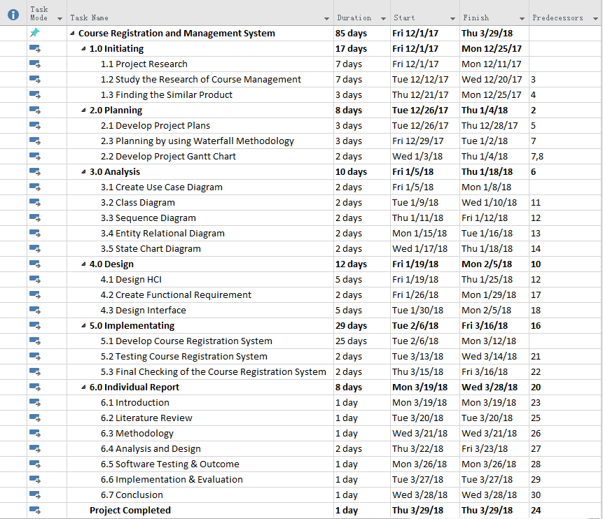

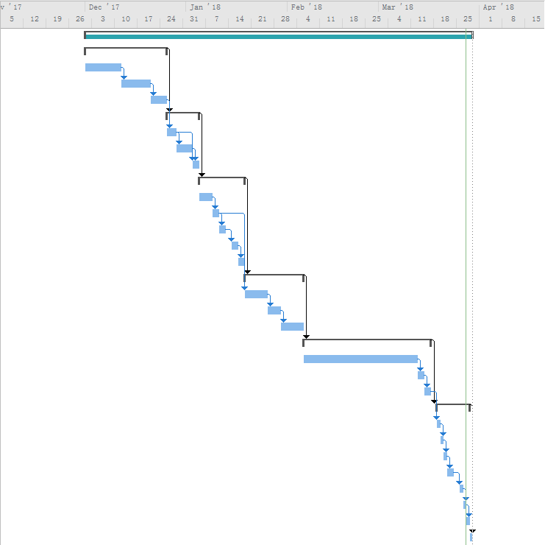

# 2.0 Chapter 2: Literature Review

## 2.1 Introduction

In the recent few years, many large and small companies have started to change their traditional business to online business. Because it is convenient for others on the Internet, everyone needs only an internet connection to access someone's website to do what they want. To give an example, someone who accesses the internet because he wants to buy the product he wants on the Internet, such as clothes, beauty products, and so on. Alibaba is a good example because it can be regarded as the most successful e-commerce. In addition, many colleges and universities are now using this Internet technology, the Internet Technology is Course Registration and Management System, as this system is to make their business more efficient and improve their work efficiency. For example, managing all the task from college in the management system, such as manage students and teachers, and manage the courses that students have ordered. As discussed above, there are many software development companies that have great expectations for an online registration and reservation system and saw that this system would be a great market opportunity. Examples of online reservation system are booking hotel, booking cinema, booking a flight online and so on. Therefore, the author will produce a new efficient Course Registration System in order to solve the academy’s existing system issues and improve their system’s function. Furthermore, to meet the requirement of client and user, the author will do more research on similar system because a good system is not how a developer think it is good, it is copy an idea from an existing system which the idea is accepted by all the user and client and that is why research on similar product is very important for all the software developer. This research can help the author to a better understanding of how he develops his own system. Furthermore, the author will also review for each similar system to get some idea of an existing function that everyone accepted then make this function more efficient than the previous function and implement to his own system. All the information about the similar system will be discussed and list down in this section.

## 2.2 Product Research - Advantage of Course Registration and Management System

### 2.2.1 Safe and easy way for a student to register course in this system

First of all, the first benefit of this system is that student which is the user that he can easily order course in the academy by using this enhanced system. This enhanced system will provide a clear and good user interface design for the student to view course and make any course registration. The most important for all the web system is dependent on the design. If the web application has many advanced functions but their design looks bad and make confusion for students to interact with their web application, as a result, it is pointless. Furthermore, this Course Registration web system will also provide user-friendly for all the users who use it. Therefore, the student can fully utilize all the features and functions that available to students only, such as register course. After course registration is made, students need to view their order details and make payment. In the payment info, all information and instruction are already there, information such as the course student orders, bank information and company’s email and contact number. The student needs to pay the course by the bank into company’s bank account and send evidence, such as screenshot the receipt. All the instruction and information provided for the student is because want to avoid misleading things happen. Therefore, the student can safely make payment to the company, and no need worry about their money bank-in to a bank account that is incorrect, because all bank information is already provided in payment info. **(Rattan Singh, 2018)1**

### 2.2.2 Students can register at any time in this system

Furthermore, the second advantage of this system is that it can serve student to register or reserve the course at any time. There are many online registration and reservation system are open 24 hours per day for every week, for instance, reservation and registration such as yoga class reservation, cinema seat, flight seat, academy course registration and much more. However, if an academy that doesn’t have any online registration or reservation system can cause the problem, the problem is that they may create trouble for the student to register course outside of business hour. Basically, all the company business hour is from 9 am to 5 pm. Therefore, this issues makes them difficult to register after 5 pm. However, this Course Registration System provides a 24/7 services for students. So that they can register any course at any time in this system. **(Louis-Marie Ngamassi Tchouakeu. 2012)2**

### 2.2.3 Students can use waiting list function to queue for their preferred course

Moreover, the third advantage of this system is that it provides a function that allows the student to add their preferred session to the waiting list. The student use waiting list function is when there is a session already full but the student still preferred that session, so that they can use this waiting list function to queue for it until someone cancels the session. This function gives student more convenient way in the register a session that is not available. The author has done research on a similar system, but so far didn’t see any of this similar system has this function. However, if for traditional Course Registration System then it may bring some issues for the student because the student needs to manually check their preferred session until it is available. In this situation, it will bring inconvenience to students, as they need to check it for themselves. Therefore, that is why the author thought of a function to help solve this issue which is call waiting list function. **(LOS ANGELES COMMUNITY COLLEGE, 2017)3**

### 2.2.4 Lecturer can easily view the timetable and record attendance

In addition, the fourth advantage of this system provides a function that helps lecturer to record student attendance with the convenient way by using this web system. Normally, a course needs to take 2 or 3 days to finish it. Therefore, if a course that takes 2 days which mean it has 2 sessions for that particular course, then lecturer can select the course and system will display a modal box which displays how many sessions for the particular course and then select for a particular session. With these functional flow that allows a lecturer to fully understand how this function works and know which progress they are in. Furthermore, with the traditional attendance record, it may produce a false attendance. Other than that, without attendance record function then the lecturer needs to more paperwork which is more works to do and also waste time by record attendance in the traditional way. Therefore, that is why the author thought of this function and want to implement this function in the system in order to prevent these issues happen at this company. **(Sriram, 13th May 2016)4**

### 2.2.5 Reduce workload

Finally, the last advantage of this system is decreased and reduce the amount of work to be done by admin or employee. However, there are many academies or any tuition centre doesn’t have this course registration and management system. It is because of these companies afraid of spending the amount of money on the system that is why they were preferred to use traditional way or tools to help the student to register their session, instead of using an efficient system to make their work easier and reduce their workload. If an academy doesn’t have this course registration, this issue may cause them to increase their workload and all their works have to do manually, such as the attendance record need to do in using paperwork and all the data record may need to record in Microsoft Excel. Furthermore, there is some similar product researched by the author, the system’s function is when students are interested in a course that academy provides, but they need to send an e-mail by using their system and then need to wait a couple of hours or days to get a response from them. This is considering a nice function but it needs take maybe a few couple of hours or days to get response from that particular academy, so that if a student that are impatient and they don’t like to wait for so long then they will rather go to another academy website that provides a function which much easier for them to register a session than the previous one. Therefore, the author is thought of this idea, if this academy need to survive in this market competition and beat down their competitor then they need a system that provides an efficient and convenient function to their beloved users and that is why Course Registration System and Management system idea came out from the author to prevent these issues. (**YILIN LI, 2017**)**5**

## 2.3 Research and Review of Similar Products

### 2.3.1 iTrain

the iTrain company is the first to lead the digital technology in Malaysia. The iTrain Company are first who provides the Information Technology course of training in Malaysia, such as HTML, Android and iPhone. Other than that, this iTrain company also provides the certificate of Google, the certificate is called ‘Google Certification Programme Training in Southeast Asia’. iTrain provides this certification in few countries in Southeast Asia, which are Malaysia, Singapore, Indonesia and Philippine. Furthermore, iTrain not only provide courses that already mention above but the company also provides such courses, such as pioneered Cloud Computing and Green IT certification course in Southeast Asia, which are Malaysia, Singapore, Indonesia and Philippine. iTrains goals are to provides excellent training services for their students or their learners that different from others academy’s training services, to make their learners to fully understand and absorb what they teach in the training session. Now the author will be discussing Course Registration System of iTrain. In researching this system, the author found that their system does not require any login function. The interface design of this system is perfect and with a user-friendly design. Furthermore, above the navigation menu, the system provides the information of this company, such as telephone number, company address, their business working hours and their social media profile, such as Facebook and Twitter. Therefore, when users first access to their website then they can see the company information easily so that they can contact them for asking the information of course registration or go directly to their company address and apply for the course according to the company information where the website provides to the users. That is why they provide that information because it is very useful and helpful for their users who are lack of computer literacy and unable to understand their system. Moreover, there are four menus in the navigation menu which are Home, Course, About Us and Benefits. The author will clarify each function of their course registration system. The homepage is only information and introduction to their company. For example, what benefits they provide for their users, such as a corporation, individuals and universities. In the home page, there already list down few of their course which provides by iTrain academy with some details. In additional function, there is a course menu which lists down all the available course that provides by iTrain in a kind of drop-down list menu, and all courses are listed down in the menu have iOS, Android, IoT, Data Science, Project Management Professional, and Microsoft Office Training. The courses they provide are quite similar to IT Academy Asia. However, when the user selects a specific course from that menu then it will link the user to the specific course page for more information and details about the course that user preferred. Moreover, there is an “Inquire Now” button in that particular course registration page. Therefore, when the user clicks the button it will pop up a modal box which displays the form for the user to fill in, such as First Name, Last Name, Email, Phone Number, Company Name and Position. Once the user submits the form, then need to wait for few couples of hours or maybe another day for getting an e-mail from their staff. All the information about the course will be clearly written in this e-mail, such as the intake of this course, and price of this course. Once the payment is completed, their staff will contact the user’s phone number and double confirm it.



Reference Link: <https://www.itrain.com.my/>

### 2.3.2 The Knowledge Academy

The knowledge Academy company provides the most training courses in this world. They have more than 25 years’ experience in providing their high-quality training services. Furthermore, they deliver and provide more than 30,000 courses, in a different location and across more than 200 countries. Moreover, all the course of price is unbeatable in the world, this company is very flexible to their user’s needs because the user can choose their options for the training class, such as classroom, onsite, virtual and online training. Their goal is to provide the best training and with the lowest price in this world, it is why they mentioned that all of their courses of price is unbeatable in the world. The author has already researched their website and function that provides to a user for course registration purpose. The user interface design is almost similar to the previous review of the similar product, which is an iTrain academy. What it looks similar is that they provide the information of company above the navigation menu and the different thing is that user can select for their country, such as United Kingdom, United State, Australia, Malaysia and so on. This is what makes The Knowledge Academy success, they provide all the functionality that is flexible, user-friendly website and also convenient to all their user with different countries. There are four menus on their website, for particular menu has its purposes. The first menu is Courses, the design of this menu is very good because it listed down all the categories very details, and with different categories has different courses. For example, in IT securities category, it includes Certified Ethical Hacker Training, Cyber Security Training and much more. For another example, in Programming and Database category, it includes SQL Training, Java Training, Programming Training and much more. Once user selected for a specific course, then the website will link the user to the page of that specific course with more information and details written on that page. Furthermore, in that specific course web page, the user can select the delivery method that they are preferred, which are Classroom, Virtual, Online and In-House. Moreover, the user needs to select the location according to the country that the user selected previously. For example, the country is selected in the United Kingdom then in the specific course’s web page will display a list of the classroom in the table only if it is available in that location, such as Manchester, London and more. In addition, the list of the classroom in the table has two interactive buttons which are enquired and books now. For the enquire button, when clicked it will lead the user to below of the web page and a form for the user to inquire more about this course by sending them an e-mail. For the book now button, when the user clicked it then it will link the user to a new web page which is payment gateway. Then the user needs to fill in all the information that is required and choose one payment method, such as Credit or Debit Card. Once payment is completed, then the system will automatically send an e-mail to the user and give a call to make sure everything is fine.

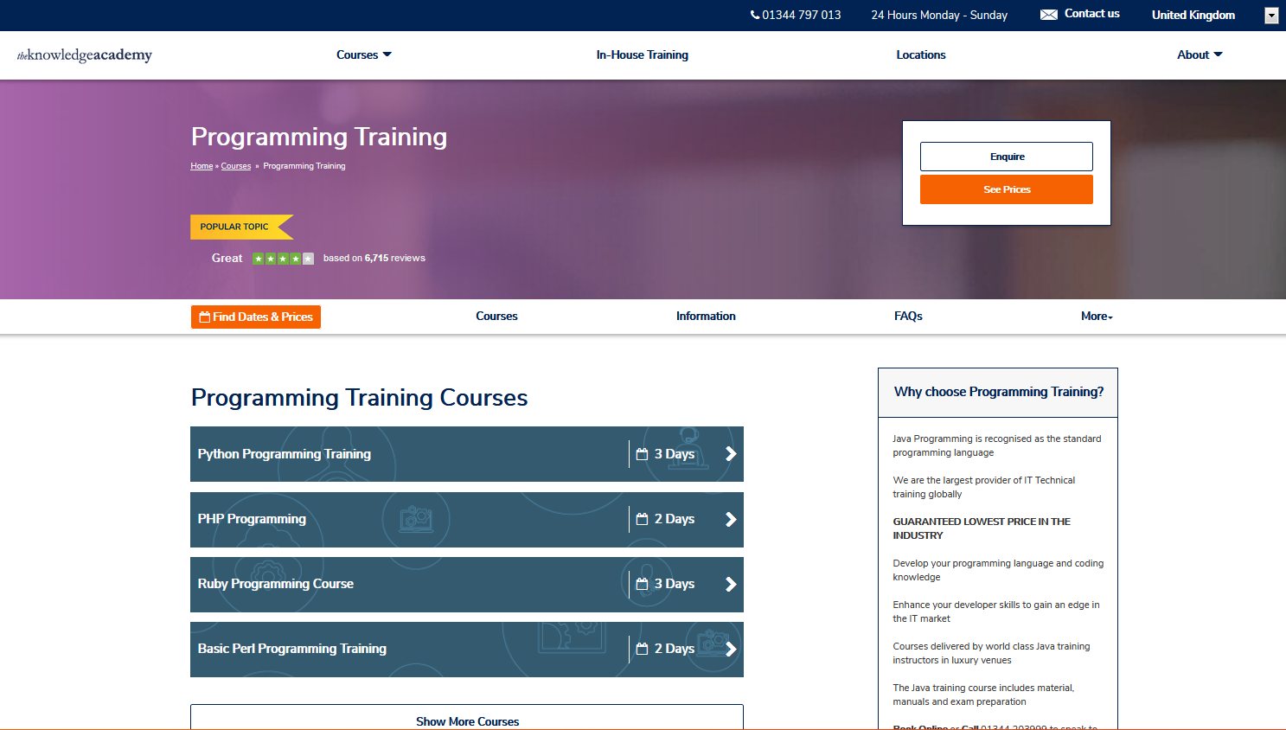

Reference Link: <https://www.theknowledgeacademy.com/>

### 2.3.3 Asia Dev Academy

As what the author has research on the system of Asia Dev Academy, there are 2 awesome academy companies has already joined forces to Asia Dev Academy, which are Asian Tertiary Education (BAC) and iTrain. Moreover, with these 2 academy companies, it can provide the best quality service and teach to their students. About their Course Registration Web System, all their pages are designed in a single page. Furthermore, there are 6 menu navigations, which are Home, About, Programme, Why Code and Code Games. For the Home page, it is just some description about what benefit and courses they will bring to their students. For the About page, it is just the description of their company background. For the mission page, it just some description of their mission to meet the requirement of their objectives. For the Programme page, it is like a product list that shows all the courses. Therefore, the student can read what subjects is provided by the particular course. However, students must send an inquiry to the academy in order to make a further step to register the courses.

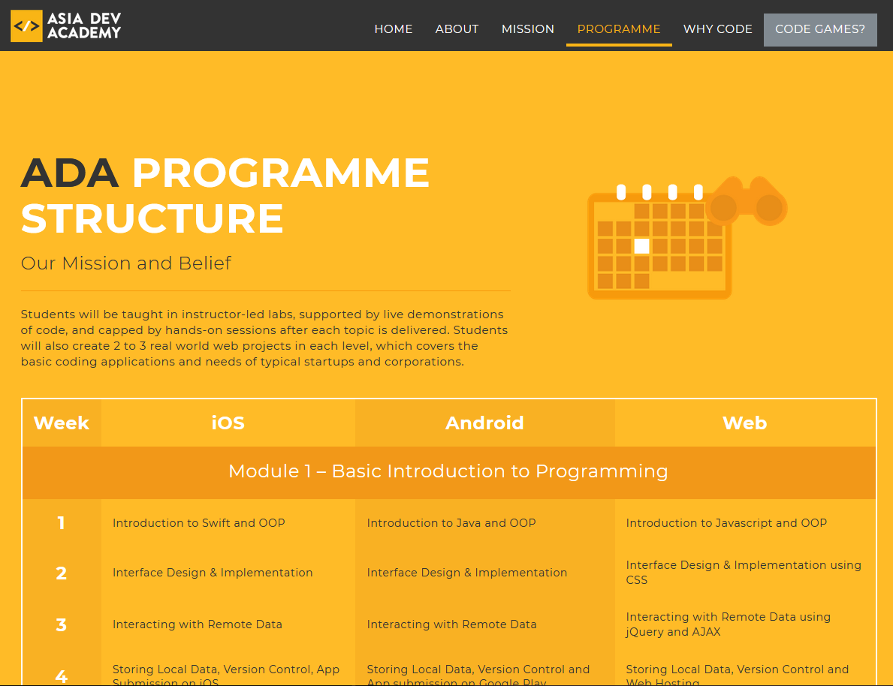

Reference Link: <http://asiadev.academy/>

### 2.3.4 Next Academy

NEXT Academy was in Southeast Asia, this academy trains world class and provides a high-quality teaching service to their students and junior developers. For their Course Registration Web System, it has a login function provides to their student. However, it doesn’t require the student to log in before making course registration, the student can directly make payment without login. Furthermore, their system payment gateway is quite similar to any others e-commerce website. The course registration flow is the first step to choose a course, the second step is to select the intake or session, next third step is to fill in student’s information with email username and password, then the last step is fill in the payment information. As their system is quite similar to IT Academy Asia’s Course Registration Web System. However, the difference between these 2 web applications is that the IT Academy Asia’s Web System provides a waiting list function for students to queue for the unavailable session. Furthermore, it also provides lecturer to make attendance record in the system conveniently. Therefore, the lecturer can be avoiding to manually key in the attendance data record in the Microsoft Excel as well as using paperwork. However, compare to Next Academy’s Web System, this system is still not that perfect. Therefore, the author will try all the best to improve the Course Registration System of IT Academy Asia.

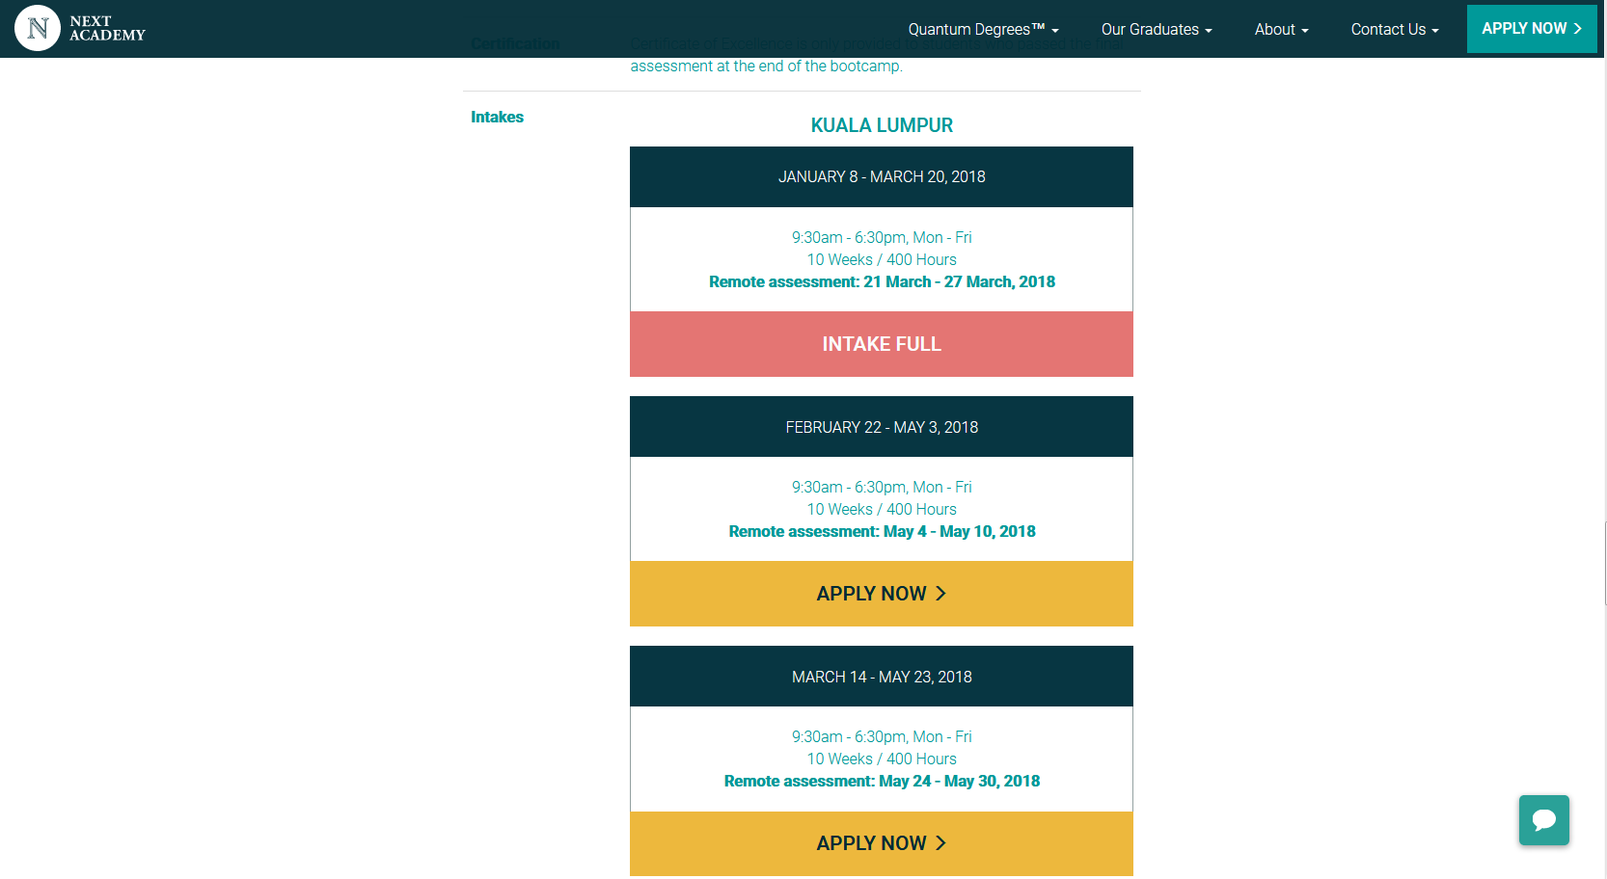

Reference Link: <https://www.nextacademy.com>

### 2.3.5 Skill Based IT Training

SBIT Training Academy provides all the IT Training course, such as programming and computer hardware. SBIT Training Academy is located in Kuala Lumpur, Petaling Jaya Area. This academy is only providing Professional Technical Training Services. Their expertise is providing the technical training services, designing and more. For their web system, it doesn’t provide any login function for student and trainer. In their system, for the student to make course registration, they need to select for a particular course, need to fill in the inquiry form and send it to SBIT email. After that, the student has to wait for their staff to reply them and show them the available session or intake. Overall, their course registration system is considered not bad. However, some potential students might give up to registering the course, as it needs to take time to wait for their staff to reply them the available session and intake.

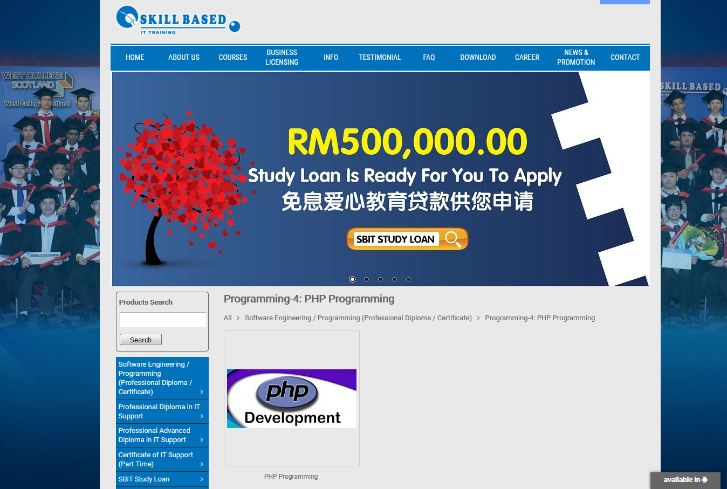

Reference Link: <http://www.sbit.edu.my>

## 2.4 Table of Comparison

In this section, the author will take this 5 similar product as a comparison. The author will take all the functionalities of the 5 similar products as a comparison. The comparison functionalities have Login Facilities, Register Facilities, Course Registration, Waiting-List Function, Online Payment Gateway Process, Admin Management, Attendance Record Function and User type.

|  |  |  |  |  |  |  |
| --- | --- | --- | --- | --- | --- | --- |
|  | iTrain Web-Based System | The Knowledge Academy Web-Based System | Asia Dev Academy Web-Based System | Next Academy Web-Based System | Skill-Based IT Training Web-Based System | IT Asia Academy Web-Based System |
| Login Facilities | Yes | Yes | No | Yes | No | Yes |
| Register Facilities | No | No | No | Yes | No | Yes |
| Course Registration | Yes | Yes | Yes | Yes | Yes | Yes |
| Waiting-List Function | No | No | No | No | No | Yes |
| Online payment gateway process | Yes | Yes | Yes | Yes (Better) | No | Yes |
| Admin Management | Yes | Yes | Yes | Yes | Yes | Yes |
| Attendance Record Function | No | No | No | Yes | No | Yes |
| User type | 2 | 2 | 1 |  | 2 | 3(Student, Lecturer, Admin) |

## 2.5 Course Registration Research

### 2.5.1 Online Course Registration

According to Johnson and Manning (2010), the time and technology are the biggest key point of differences between online course registration and paperwork course registration. For paperwork course registration, the student needs to fill in all their information in the hardcopy form and then purposely submit it to the particular IT Course Academy, which is time-consuming. However, the online course registration helped to solve the time-consuming issues, as it provides a technology, which let the user make any course registration conveniently and easily, without submitting the hardcopy course registration form in some others academy. Furthermore, this kind of technology brings student lot of advantages, such as improving the procedure of registration into the further level. In the online course registration system, the potential student can find more information about the academy and courses information as well as the payment information. Moreover, students can register their account and login to view more available course and sessions. The staff can view the list of request orders that made by the student. Once the staff received an evidence receipt email, then will approve the payment. Therefore, the student can view their timetable in the course registration system. Overall, the course registration and management system can bring a lot of advantages to staff and students, as this technology help them to save a lot of time as well as bring a lot of conveniences. **(UKEssays, 2018)6**

### 2.5.2 Online Course Registration and Management System

According to Johnson and Manning (2010), an Online Course Registration and Management System has an ability to provide functionalities to maintaining and managing the entire course registration flow for students. Furthermore, it also provides functionalities for the admin user to maintaining and managing the courses, session and users account information. Moreover, it also has an ability to create, read, update or delete all the content of a system. Nowadays, there are many companies’ web systems provide the ability for the admin user to managing the registration online, such as the company of iTrain, Next Academy and so on. Some of their website management system is user-friendly, while others are more advanced, as there are using up to date technology. Besides, there are few programming like PHP or ASP.NET are all supported the web-based programming language to develop the online course registration and the management system. After finish researching all the information that is related to course registration and management system, the author understands that a perfect system must meet all the requirement and also provides a quality service to their end-users as well as generate a statistical analysis report and graphs to the administrator to analyse all the potential data. **(UKEssays, 2018)6**

## 2.6 Tool and Software Research

### 2.6.1 MySQL

MySQL is a development project which is an open source to all users, which it is available and free for all the people who use it. However, there are various terms of open sources, such as General Public License and others types of agreements. MySQL AB was started in Sweden, in 1995. In 2010, a company that named Oracle Corporation has bought the MySQL, which mean MySQL AB has already owned by Oracle Corporation. Currently, MySQL is supported by any types of the recognized web application. For example, PHPBB, Joomla and more. Besides, there are also many famous websites like Facebook, Google, YouTube and more are using the MySQL as their Database system. Therefore, the database of course registration and management system will be using MySQL, as it has an ability managing database table by using relational database management system. Furthermore, it also supported to save as a related table. As the course registration system is a web-based application so that it is the highest recommended for using MySQL. Other than that, MySQL also supported multiple programming codes like PHP, C++, Python and Perl to managing the database tables by executing the queries. **(SearchOracle, 2018)7**

### 2.6.2 PHP

First of all, PHP is also known as Personal Home Page, which means a personal website. In 1995, the PHP programming was created and invented by Rasmus Lerdorf. “Personal Home Page Tools” these keywords are where the PHP initiate from. Previously, it was used to create their website. However, after that, the PHP tools was released under the GPL, in 1995. Moreover, it has used the MySQL database to access its functions, such as insert, update and delete queries. Recently, it has more and more users using the PHP tools as it was released under GPL also known as open source license. Furthermore, there are more developers who also invented more libraries for PHP, such as Laravel and CodeIgniter Framework. Besides that, the PHP already upgraded several advanced versions recently, which including more advanced functions and syntax. As the author has mentioned before, that the PHP was initiated from a tool that uses developing a web page, now the PHP developers are inventing more advanced functions that related to web application development. Overall, it was created to run as the Apache HTTP Server which frequently using the server-side web application development. **(www.guru99.com, 2018)8**

### 2.6.3 HTML

First of all, the HTML was used to describe web pages. The HTML also used to describe the data, such as it can be embedded as images, movies, sounds and more on the web page. The purpose of using HTML is designing the web pages, also it compatibles with the news and e-mail in HTML 2.0. Furthermore, the XHTML which has an ability to converting from HTML to XML language. However, in the web page file, it has 2 types of extension which are “HTML” and “HTM”. All the HTML entities are being used in the HTML files. Furthermore, the image can be placed on anywhere in the same web page, as the HTML file only stored the information of the image and stated where to place it. However, it is requested to mark up in a proper form considering the viewer, as far as information is disclosed to the whole world I will. For example, <u>, <s>, <strike> are deprecated as they describe the appearance. Incidentally, tags describing the appearance of <b>, <i> are not deprecated. (**Ross Shannon, 2018)9**

### 2.6.4 JavaScript

The present activity is a primary JavaScript system. Since HTML and CSS alone cannot do such handling the author personally think whether it will become a whole new world. It would be exciting. Although it has software and a name, it is a full-fledged growth terminology in comparison with HTML and CSS, and the problems level is great. Furthermore, a system is a common phrase for 'languages' that work as it is after composing resource program code. So a little nuance such as a simple terminology is roofed. And understanding of HTML and CSS is important to enhance studying JavaScript. The author suggested that should begin studying JavaScript after make and experience various sites on the writer own and to develop to some degree efficiently. Developers doing for many years have great abilities who can make various 'languages', but there are such tricks. Furthermore, here is the point of note! "JavaScript" and "Java" are completely different things. In addition, it is the growth terminology offered by Oracle Organization. Java is used in PC database integration, and lately, it is creating Java on an Android operating system in Java-like terminology. Moreover, as the author described previously, the system is a common phrase for 'languages' that will be implemented as soon as we make this method. **(MakeUseOf, 2018)10**

### 2.6.5 Notepad++

Notepad++ also known as source code editor, it is designed for the user who wants to write a different type of code, such as PHP, JavaScript, HTML and more are all available to edit in this notepad++. Furthermore, it is also designed for the user who is using the Microsoft Windows. Moreover, it allows the user to open more than 1 files in a single window. For instance, the author can open multiple PHP files to do the comparison. The reason why the author used Notepad++ is that of simplicity. Furthermore, the author is available to use the debugging tools in Notepad++. Therefore, it can be easy to track down all the errors and bugs, which bring more convenience to the author. **(TurboFuture, 2018)11**

### 2.6.6 Microsoft Office

Microsoft office is designed for the user who needs the productivity applications. However, there are 2 types of user, which are office or business use. In 1950, the Microsoft Corporation was first launched and released the Microsoft Office Product. Furthermore, Microsoft Office is supported different languages. Moreover, Microsoft Office also supported a variety of operating systems, such as Windows, Mac and Linux. This Microsoft Office including many useful tools, such as Microsoft Word, Excel, Visio and Project. The author will be using for Microsoft Word, Visio and Project. The Microsoft Word is used to writing the documentation. For the Microsoft Visio is used to design the analysis diagrams, such as Use Case, ERD, Class Diagram and more. Lastly, the Microsoft Project is used to create the Gantt chart. **(Techopedia.com, 2018)12**

## 2.7 Conclusion

In this chapter which is the conclusion of literature review, the author will be summarizing and clarify each of the chapters of the literature review. First of all, the author had already completed explain all the benefit and advantage of this system. All the benefit and advantage function that need to implement in this system is researched by the author from the internet, such as google, yahoo, and much more search engine. During the research of this system, the author found that more than five systems are almost similar and related to the current system that needs to develop. For instance, iTrain, The Knowledge Academy, Asia Dev Academy, Next Academy and Skill-Based IT Training. All of these academy’s website design and function are perfect so that the author can get more idea and benefit from these researched similar products. Some of the websites which are The Knowledge Academy and Next Academy that give inspiration to the author is that this website uses a way to purchase a course that quite similar to e-commerce, such as Lazada, Alibaba and so on. Therefore, the author will take it as part of the idea to implement this function on Course Registration System. Furthermore, there are few academy’s websites that list their course in categories and when the user selected a particular course it will display all the classroom for that particular classroom. This kind of idea is not bad because it shows that it is very systemization, and easy for the user to understand which classroom is belonging to which course. Moreover, it can avoid confusion for the user to find the course’s classroom. Therefore, the author will also take this idea to implement this Course Registration System. Lastly, it can help the author to understand and gain more knowledge about this Course Registration System on market.

# 3.0 Chapter 3: Methodology

## 3.1 Introduction

In this chapter 3, it is all about the methodology that used to develop the course registration and management system. The methodology development will be using the Waterfall Model Methodology, as the author has some knowledge of this method. Moreover, it uses linear-sequential life cycle model, which mean there are no overlapping for each stage. Next will be discussing the tools and software that use to develop the system, the author will be using the MySQL, PHP, HTML and JavaScript. Besides that, it is the fact-finding, survey and questionnaire feedback in graphs.

## 3.2 Methodology Development

For the methodology development, the author has decided to use the Waterfall Model Methodology to develop this project of course registration and management system. Waterfall Model Methodology has already come with many years. Therefore, it is a method which considered very useful and famous in software development lifecycle. However, this method has only one way to perform, which is also referred to linear-sequential life cycle model. Since it is linear-sequential life cycle model, there will be no any stages for overlapping, as each of the stages must completely finish only can proceed to a further stage. Nevertheless, some overlapping stages are still acceptable to use in Waterfall Model Methodology. Moreover, Waterfall Model Methodology is considered simplicity and easy to understand. Therefore, the author willing to choose the method, as the author also has some knowledge in this method, it is the best choice for using this method. The principle of waterfall model is that it only focus on specific implementation, budget, planning, time and deadlines. Besides that, the next principle of waterfall model is its strict control on every stage. For instance, the completion of all stages must have produced an overall documentation. Other than that, the user and IT management must require to sign off the testimonials. **(Airbrake Blog, 2018)13**

### 3.2.1 Requirement

For the waterfall model first stage is a requirement. About this stage, it requires the software engineer to find about the information requirement that is related to the system and collecting it, then saved it in a specific file as reference. After collecting all the information required, it will take those requirements to analyse the data. Therefore, the author will be collecting all the requirements that are related to course registration and management system and then start for analysis all the requirements, such as how others manage their course registration system.

### 3.2.2 Design

For the waterfall model, the second stage is about system design. After finish the Requirement Stage, the author has completely done the research which has already gathered and analyzed all the requirements in order to proceed next stage which is design. The design part of the course registration web application is all depending on the end-users requirements, as the end-user want the web design to be user-friendly and simplicity in order to let their client use their web application comfortably. Therefore, the course registration system must be easy for the user to understand the entire procedure and system flows.

### 3.2.3 Implementation

For the waterfall model, the third stage is about implementation. After finish the web application design, the next stage is to start implementing PHP programming code for all the functionalities that requested by the end-user. The author will be choosing the Notepad++ as IDE for PHP programming language. After finish implemented all the functionalities, it will proceed to next stage which is unit testing, which is for the tester to complete all the functionalities of each test unit.

### 3.2.4 Testing and Integration

For the waterfall model, the fourth stage is about testing and integration. After completely implemented all the required functionalities, then it will proceed to integrate all the functionalities into the course registration system. After finish integrated into the course registration system, then it will do more testing on this course registration in order to find out any potential errors, then fix the errors before the web application goes live.

### 3.2.5 Installation

For the waterfall model, the fifth stage is about deployment of the course registration system. After finish testing the functionalities and non-functionalities of course registration system, it will proceed to installation stage, which helps IT Academy Asia company to install the enhanced web application into their web server and help them to live their web application.

### 3.2.6 Maintenance

For the waterfall model, the fifth stage is about maintenance. After finish the course registration system installation, it will definitely come up with many issues and bugs, as the tester cannot be fully tested the entire system. Therefore, we need the client to give more feedback that regarding issues from the web application, so that the author can easily fix all the bugs and errors in order to make the web application bugless and errorless.

## 3.3 Tools and Software that uses to develop in Course Registration System

### 3.3.1 MySQL

The author will be using the MySQL as the database, as it was flexibility and scalability. The reason why MySQL is scalability is that it can handle a maximum of 1 TB (terabytes) of huge data in the warehouse database. Other than that, it is also considered flexibility, as it can support a variety of operating systems, such as Window, Unix and Linux. Moreover, MySQL has an ability to provide the user with customization the server of the database. It was suitable for the author to use MySQL as the database of course registration system, as it can have multiple choice of configuring the server of the database. This is also the requirement of the end-user, as they want a database that can support multiple choices.

The first benefit of MySQL is powerful data protection and security. Moreover, MySQL provides database authentication, it was the best feature for allowing users who have permission to access to particular MySQL database server. Therefore, if any unauthorized users try to access for particular MySQL database server, it will proactively prevent users to access it. There are 2 securities provided by MySQL, which are Secure Shell and Secure Sockets Layer, it supports users to protect the connections and make it safe. Furthermore, there is more third parties’ software that available for MySQL, such as a third-party software that provides the user with a feature which can make a logical or physical backup of the database as well as sync recovery.

### 3.3.2 PHP

As we know that, all the famous social networking website like Facebook and Twitter are all using the PHP framework. Therefore, the end-user has also requested the author to use PHP programming in their enhancement web application. Furthermore, the reason for the author to use PHP programming to develop the course registration and management system is because it brings a lot of benefits. The first benefit of PHP is very simple to use, as PHP language and syntax is quite similar to the English language. Therefore, it is quite easy for a new web developer to understanding the existed PHP web application, and also it takes effortless for a junior programmer to learn PHP. For the second benefit, the author can be easily seeking for help, as the PHP is a famous programming language and the almost worldwide programmer is using PHP. Therefore, the author can be easy to find the best solution to solve the problems, and mostly the author will find the solutions in the programming forums, such as Stack Overflow Forum. For the third benefit, the author personally thinks that PHP is diversity, as it can use multiple IDE to write PHP programming language, such as Notepad++, Sublime, NetBeans, Eclipse and more. Therefore, the author can have multiple choice of using the IDE, Notepad++ will the best choice for the author to write PHP programming. For the fourth benefit, there multiple frameworks for PHP programming language, each of the PHP frameworks have its own advantages and disadvantages. The author will not choose to use any PHP framework but a raw PHP programming language with object-oriented design.

### 3.3.3 HTML

HTML is most important for a web application, without the HTML then the web application cannot work, as it cannot display the web design by using HTML. Therefore, the author is using HTML to design the web application with Bootstrap CSS library. Furthermore, HTML is Open General License, it can be used by all the users who want to design the website. Therefore, the author can be easily looking for the best solution to design the web application, as HTML is open source to everyone, which mean there is also worldwide user is using it. Moreover, HTML is easy for everyone to learn, as all the HTML basic syntax are all listed down in the online resources, such as W3Schools. Therefore, the author can easily design the web application, as there are many HTML resources at online that can take as references. Lastly, there are many HTML templates which the author can download few HTML templates and refer to the web design.

### 3.3.4 JavaScript

The benefit of JavaScript is too simple to utilize it. Therefore, the author can easily write the code for the particular function, such as displaying a dialog box with fetching the data for displaying it. The syntax of the JavaScript is almost same with the English language. Furthermore, the JavaScript is not similar to PHP, as it will take action on client side server. Therefore, it will only take action on client side’s processor, instead of using the processor from the web server. Moreover, JavaScript also can add more features and functionality into a web application, such as displaying a real-time data in the web page without manually refresh the page, also known as AJAX features. The purpose of using JavaScript in this course registration web application is to run an automatic slide image and display the available session in the dialogue box. Lastly, JavaScript can be performing better than any other programming language, as it is depending on the client-side’s processor.

## 3.4 Fact Finding

### 3.4.1 Interview Question

Once the proposal has been approved by supervisors, the author then went to the IT Academy Asia Company and met one of their employee for interviewing, the employee called Ms. Lee. During the meeting, there are 6 questions has been prepared by the author and ready to ask for Ms. Lee’s opinion. Other than these 6 questions, the author will have asked for what are the functional and non-functional requirements that they wish to implement in the system.

1. How this IT Asia Academy use the system to record the student’s information, such as student profile, student’s classroom and more?

**Ms. Lee answer:** So far we are using Microsoft Excel to record all the data and some of the data is using paperwork.

1. There are how many courses that available for the student to make course registration?

**Ms. Lee answer:** It depends on the academy, as now we only have IT courses, such as Programming and Microsoft Office. There are few classrooms only for particular courses.

1. What if the session is not available for a student?

**Ms. Lee answer:** Currently, our system doesn’t have the function that allows the user to add classroom into the waiting list. Therefore, we have a request for you to help implement this functionality.

1. In the system, how the student make payment for course?

**Ms. Lee answer:** In our system, we only support for student bank in money to the company bank account, then screenshot the receipt as evidence and send it to our email.

1. How does the employee record the information?

**Ms. Lee answer:** Our employees are using the Microsoft Excel manually key in the information and sometimes will do it in paperwork. For instance, the data records of users, courses and classroom information are all stored in the Microsoft Excel.

1. Do you think the current system needs to be enhanced?

**Ms. Lee answer:** Of course, the current course registration system is not conveniences to all the users. For instance, the student doesn’t have a proper way to make any course registration, also they cannot login to their account to view the timetable and order request. Furthermore, trainers and staffs don’t have a good system to do all their task, such as managing the tasks. Therefore, we are very grateful for your sincerity to help us improve our system.

## 3.5 Survey

One of the purposes for doing a survey is that it can help the author to get an accurate and specific data from the specific group of respondents, as the author gives a set of questionnaire to the specific group of respondents to get their feedbacks. This group of respondents are a larger population of interest in this course registration system, such as students. Generally, there are many types of a survey that can be performed, such as phone call, email, person to person and internet. However, the author will be using Google forms as a survey, the method will be using a set of questionnaire which provides a public link that use to give the specific group of respondents. Once completed the survey, the author will start analysis on these potential data. The author will be using the 9 step of the survey at the following. **(Unknown, 2018)14**

1. **Formulate survey keeping in mind your overall substantive and analytical needs.**

The first step of the survey is to formulate the survey and collecting the needs for survey analytical. For this first step, the author will be listing down all the issues that need to be examined. After that, to decide what is the group of respondents that must involve in this survey, such as students. Then the author will find the critical factor to measure it. Lastly, the author will be thinking what questionnaire to provide for a group of respondents.

1. **Identify particularly what method of gathering the data**

For the second step of the survey is identify what is the suitable method for gathering the potential data. However, there are many types of survey methods, such as person to person, phone call, sending email & mail, online survey and more. The author has decided to use an online survey, which are using Google Forms, it gives a set of questionnaire to a group of respondents. Furthermore, it also provides statistical analysis diagram by feedback and response from the group of respondents.

1. **Determine an appropriate sampling plan**

For the third step of the survey is identify the proper plan of sampling. In other words, it means for the author to decide the total number of respondents to participate in this survey. The author will have decided 30 feedback and responses from the group of respondents. After that, the author will have also decided for specific respondents to participate this survey, which are people who have used the course or any other registration system before.

1. **Develop the questionnaire**

For the fourth step of the survey is to thinking what is the proper questionnaire to be created. The author has already prepared a list of questionnaires that related to the course registration system. The author will be soon adding the list of questionnaire into Google Forms and share the links for the respondents who are willing to participate.

1. **Well-trained interviewer**

For the fifth step of the survey is to confirm that interviewer is professional in this field. However, there is not necessary for this part, as the author is using the Google Form online survey.

1. **Perform an early pre-test of the survey**

For the sixth step of the survey is to do testing on the survey. Therefore, it can make sure everything goes well during the real interview without any mistakes. This step is not necessary for proceed it also, as it is using online survey.

1. **Perform survey and be prepared experience with issues**

For the seventh step of the survey is to perform a survey and get ready to experience any issues that come from the respondents. There are more issues that author need to be considered, such as some sensitive question that cannot be a list in the questionnaire, as the respondents have the right to not giving the response. Moreover, the author will not list the questionnaires that are unrelated to the topic.

1. **Edit and process the data**

For the eight-step of the survey is to fix the potential data, such as some data are not fully complete, as there are some respondents forgot to answer the questionnaires. Therefore, it is not considered the survey is fully completed. However, respondents still can ignore for some questionnaires, as they do not have any idea on that questionnaire.

1. **Analyze the data**

For the final step of the survey is to collect all the data and start analyzing it. The author will be analyzing all the potential data from the statistical analysis graphs and diagrams. Moreover, all the graphs and diagrams will be shown in Appendix B.

### 3.5.1 Advantages of survey

The advantages of the survey are cost, as the author doesn’t need to pay for it. There are many types of surveys method that is considered free, an online survey is the best example, such as Google Form and Survey Monkey. These online survey platforms are very simple to use, and it provides the user with customization features that enable the user to set the specific questionnaire. Furthermore, there will not be any paper that involves the survey, as nowadays users are using the online survey, which is good for the environment as well as saving the cost.

Moreover, the advantages of the survey are scalability, as the survey is only analyzing the characteristics of respondents. Therefore, the survey is the only one that provides a huge number of capability to ensure all the potential data are collected and able to analysis based on the collected information and data in order to improve the current situation.

Furthermore, the advantages of the survey are diversity, as the survey can be conducted in anyways, such as online survey, phone call, email, person to person and more. Therefore, that is why the survey is very helpful to all the researchers, as it provides an accurate data and also easy to collect all the data.

## 3.6 Questionnaire Feedback in Graph Statistics

Questionnaire Feedback will be shown in Appendix Section, please go refer it to Appendix B – Survey Questionnaire Feedback (Click the link).

# 4.0 Chapter 4: Analysis and Design

## 4.1 Introduction

In this chapter 4, it is about the Analysis and Design of this project. There are 5 charts and diagram which will be shown in this chapter, which are Use Case Diagram, Class Diagram, Sequence Diagram, Entity Relational Diagram and State Chart Diagram. The Use Case Diagram can help the author easily understanding the particular roles and its functionalities, as it has already shown in the diagram. For instance, the student can only make course registration, view timetable, view orders, view waiting list and view profiles. For the Class Diagram, it just shows all the modules that are developed in particular class file. For sequence Diagram, it helps the author to understand the system flows easily, as it already shown all the roles, system and database inside the diagram. For the Entity Relational Diagram, it helps the author to easily design the database table, as it already clearly shown all database tables and its attributes inside the diagram. For the State Chart Diagram, it is actually same as the sequence diagram, as it provides a diagram that showed how the system flows work. Therefore, the author can easily follow the system flows to implementing the PHP code. Other than Charts and Diagrams, it will also be including the Data Dictionary and User Interface Design in this chapter. For Data Dictionary, it is the detailed version of Entity Relational Diagram, as it clearly stated the properties of each attribute. For the User Interface Design, it is just a low-fidelity prototype, which can help the author to easily design the website by referencing it.

## 4.2 Charts and Diagrams

### 4.2.1 Use Case Diagram

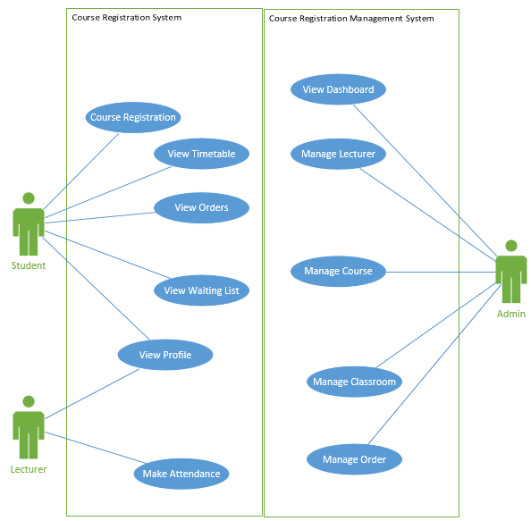

**Figure 4.0 Use Case Diagram (Top Level)**

In this diagram, it is the top level of use case diagram. It showed all the roles and its functionalities inside the course registration & management system. However, it should not be including any extend and include functionalities.

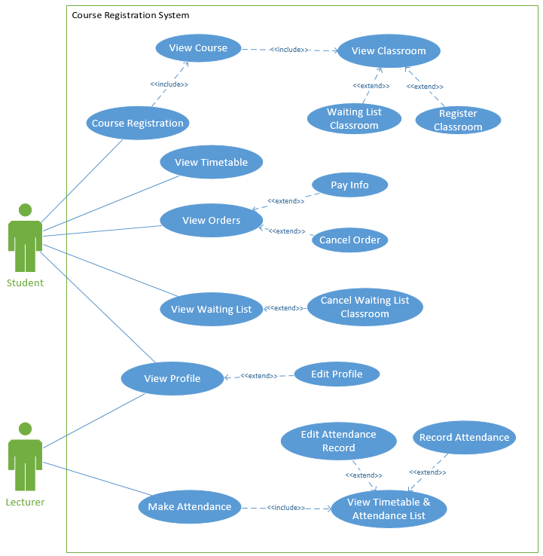

**Figure 4.0 Use Case Diagram of Course Registration System**

In this diagram, this is the detailed version for specific roles and system. Therefore, this diagram only showed the Course Registration System with 2 roles, which are student and lecturer. However, in this detailed version, it will show extend and include each functionality.

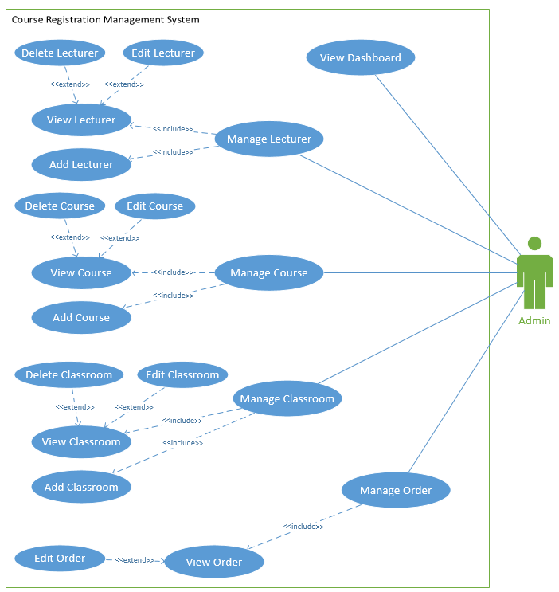

**Figure 4.0 (2) Use Case Diagram of Course Registration Management System**

In this diagram, this is the detailed version for specific roles and system. Therefore, this diagram only showed the Course Registration Management System with admin role, as only admin can access this management system. However, in this detailed version, it will show extend and include each functionality.

### 4.2.2 Class Diagram

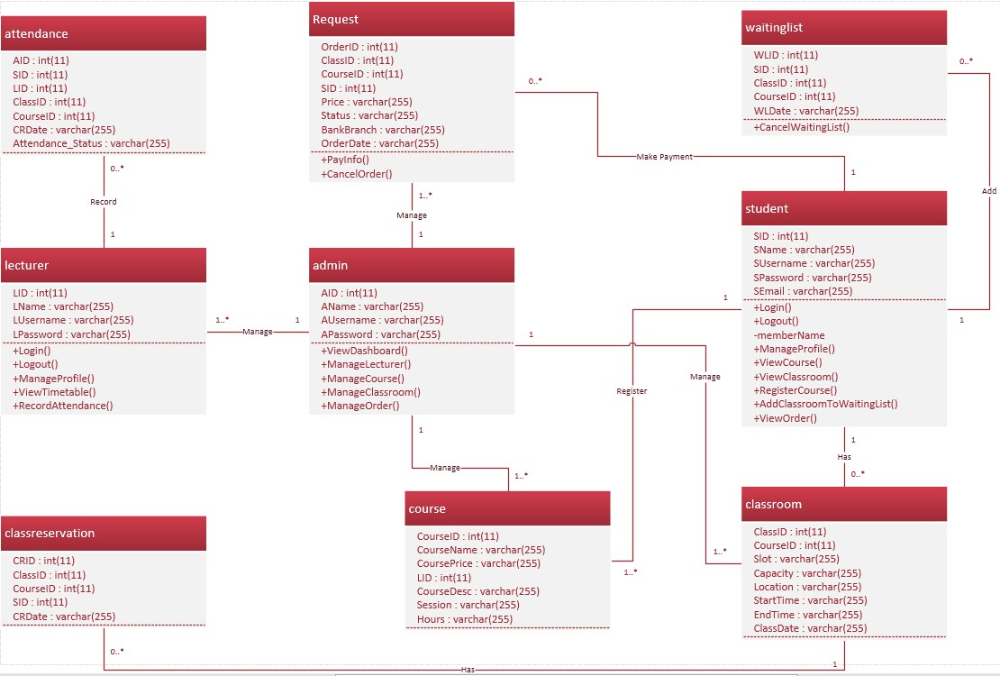

**Figure 4.1 Class Diagram of Course Registration and Management System**

In this figure, it showed each module of class. However, all classes are described as a function in a PHP file called the function. The classes including attendance, request, waitinglist, lecturer, admin, student, classreservation, course and classroom. All of these classes show its function and the database table attributes.

### 4.2.3 Sequence Diagram

**Student**

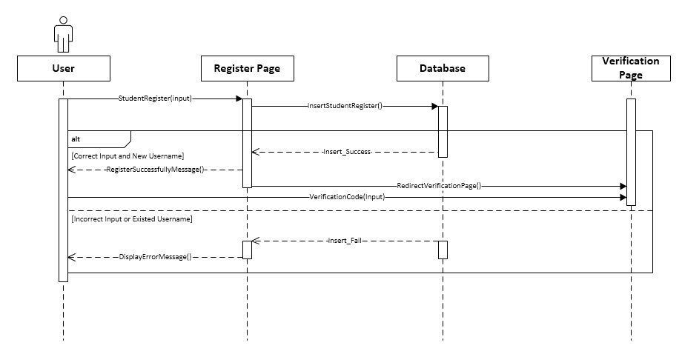

**Figure 4.2.1, Sequence Diagram of Student Registration in Course Registration System.**

In this diagram, is showed the sequence of student register an account. First they need to input the information, otherwise, it will display an error message. After that, it will fetch the insert query into the database, once success it will display success register message to the student. Lastly, the student has to proceed to email verification in order to complete the registration.

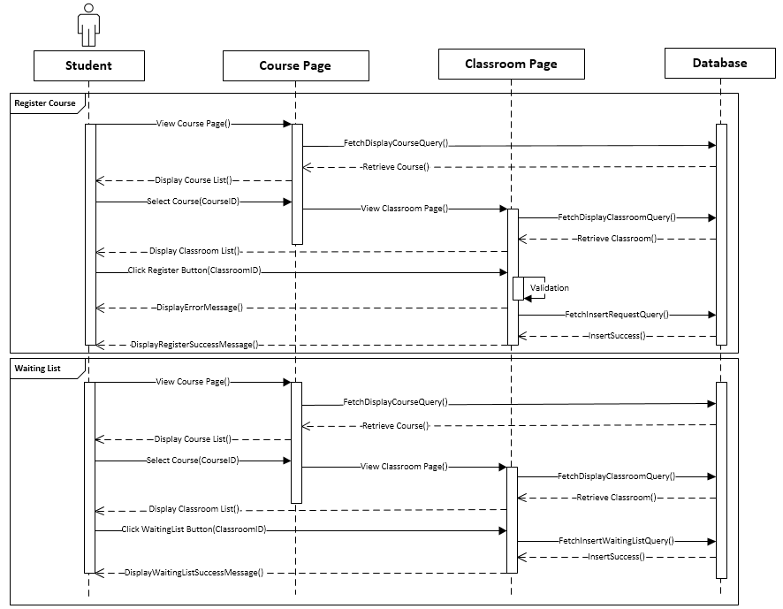

**Figure 4.2.2, Sequence Diagram of Course Registration.**

In this diagram, is showed the sequence of course registration. The first student needs to select a particular course, then select for the particular available session. There are two options for the student to select the session, which are Register Course and Add Wait List. However, the student only can register course if the session is available, while if the session is not available then student only can add to the waiting list.

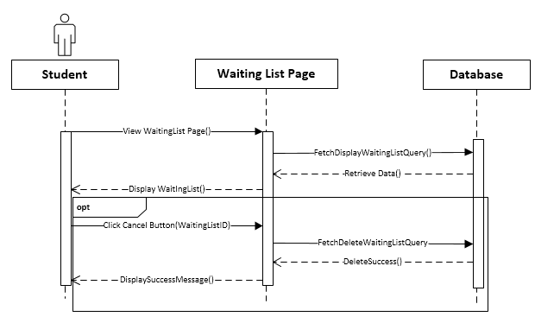

**Figure 4.2.3, Sequence Diagram of cancel waiting list.**

In this diagram, is showed the sequence of cancel waiting list. The first student needs to access the waitlist page, then select for particular waitlist record and click the cancel button.

**Lecturer**

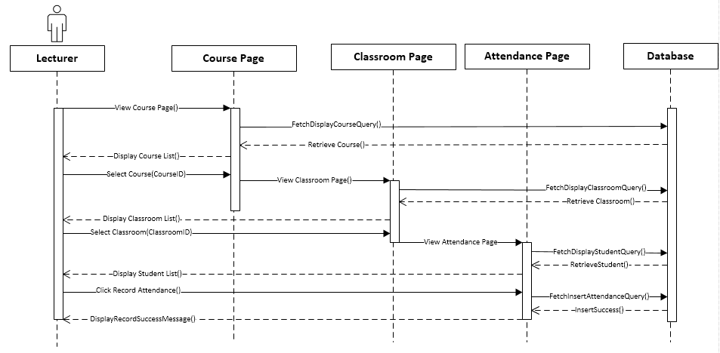

**Figure 4.2.4, Sequence Diagram of attendance record.**

In this diagram, is showed the sequence of attendance record. The first lecturer needs to select for a particular course, then select the particular session. However, the lecturer only can record attendance when the session has started. Furthermore, when the attendance was recorded, it only allows a lecturer to edit it without inserting a new record into a database table. Moreover, it also allows a lecturer to export the attendance record into excel when the attendance was recorded.

**Admin**

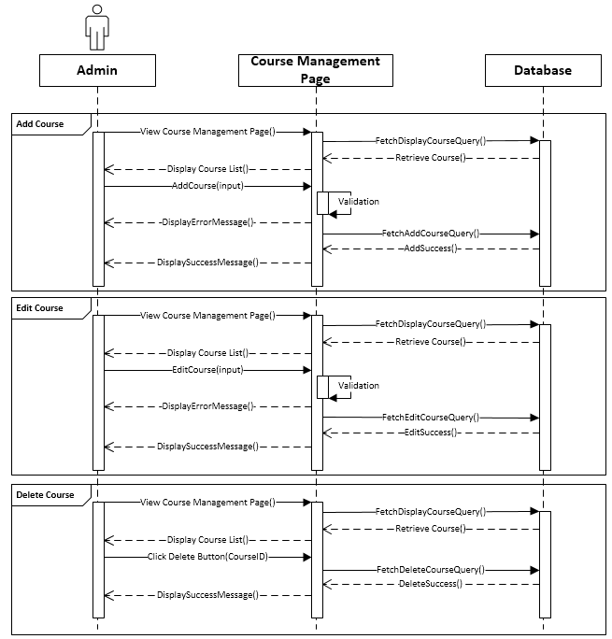

**Figure 4.2.5, Sequence Diagram of Course Management.**

In this diagram, is showed the sequence of course management. First admin needs to select a particular course to proceed the management. Moreover, admin can manage course by using the function to fetch query of the insert, update and delete.

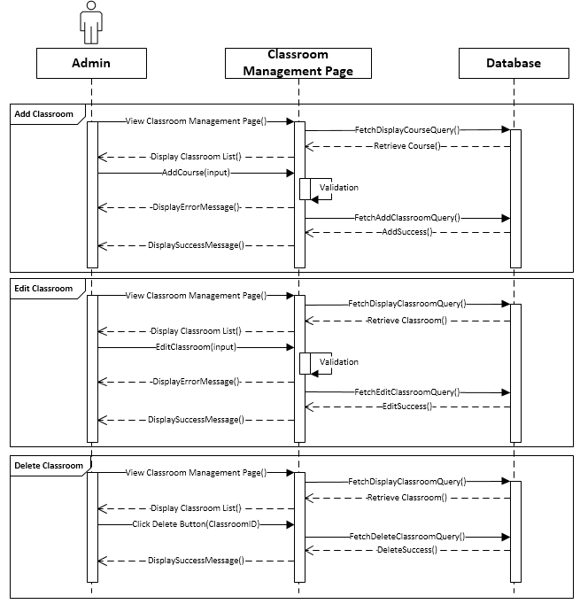

**Figure 4.2.6, Sequence Diagram of Session Management.**

In this diagram, is showed the sequence of sessionmanagement. First admin needs to select for a particular sessionto proceed the management. Moreover, admin can manage sessionby using the function to fetch query of the insert, update and delete.

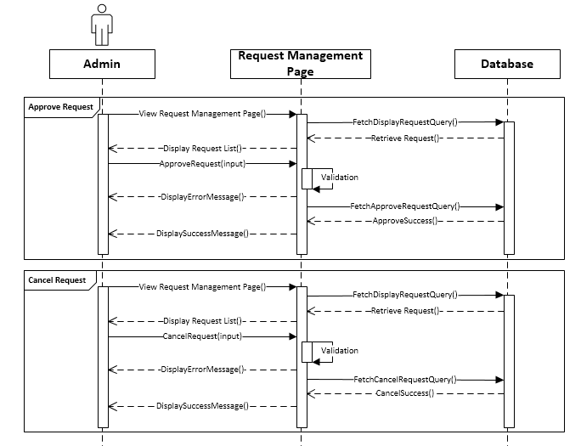

**Figure 4.2.7, Sequence Diagram of Request Management.**

In this diagram, is showed the sequence of requestmanagement. First admin needs to select for particular requestto proceed the management. Moreover, admin can manage requestby using the function to fetch query of the insert, update and delete. The admin has an ability to approve or cancel the request.

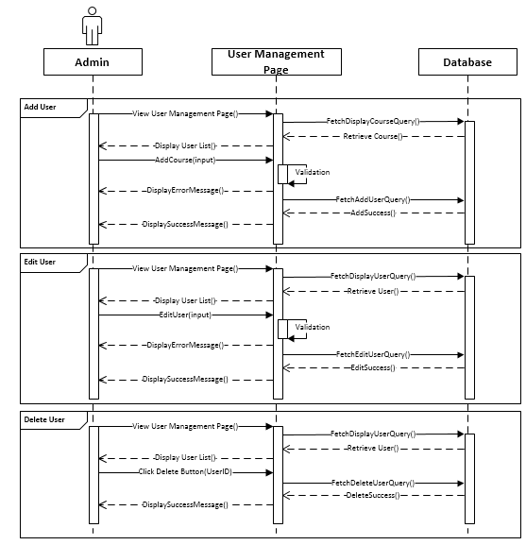

**Figure 4.2.8, Sequence Diagram of User Management.**

In this diagram, is showed the sequence of usermanagement. First admin needs to select for a particular userto proceed the management. Moreover, admin can manage userby using the function to fetch query of the insert, update and delete.

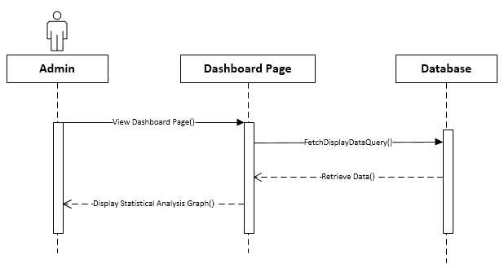

**Figure 4.2.9, Sequence Diagram of Dashboard.**

In this diagram, is showed the sequence of the dashboard. First admin needs to select the dashboard page. Then the system will fetch all the data and retrieve the data to display in statistical analysis diagram.

### 4.2.4 Entity Relational Diagram

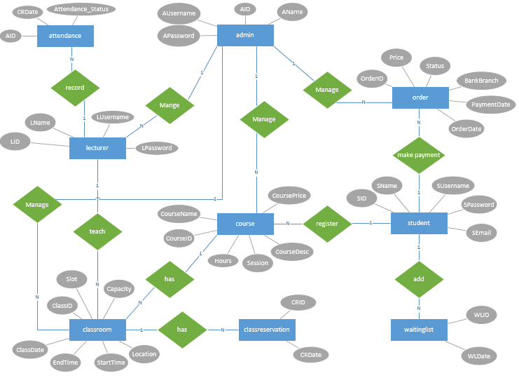

**Figure 4.3.1, in this figure it is about Entity Relational Diagram of Course Registration System.**

In this diagram, it clearly stated all the database tables and shown the relationship between the tables. There are 9 database tables in this diagram, the database tables including attendance, admin, request, lecturer, course, student, classroom, classreservation and waitinglist. Furthermore, it also showed all the attributes in each database table.

### 4.2.5 State Chart Diagram

**1. Student**

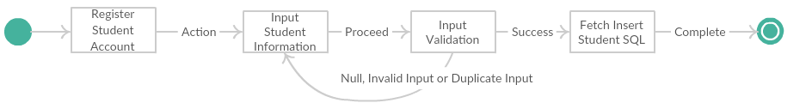

**Figure 4.4.1, State Chart Diagram of Student Registration in Course Registration System.**

In this diagram, it showed the process of student registration. Student need to input information to insert the data into the database. If invalid input, it will return back to the previous stage.

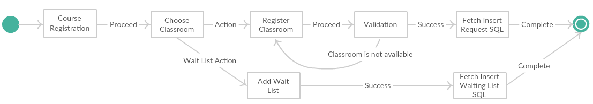

**Figure 4.4.2, State Chart Diagram of Course Registration.**

In this diagram, it showed the process of course registration. The student needs to choose available session to proceed course registration. Moreover, the student can add wait list if the session is unavailable.

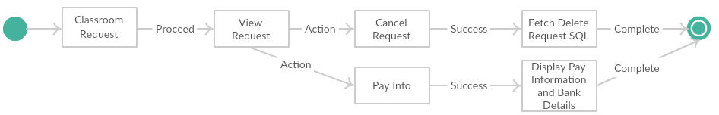

**Figure 4.4.3,** **State Chart Diagram of View Request.**

In this diagram, it showed the process of view request. The student needs to choose the request order in order to proceed the actions, the actions which are pay info and cancel the request. For pay info action, it will display the pay information and bank details, while the cancel request action will delete the current request from the database.

1. **Lecturer**

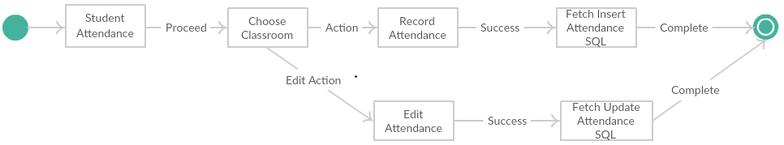

**Figure 4.4.4,** **State Chart Diagram of Attendance Record.**

In this diagram, it showed the process of attendance record. Lecturer needs to choose the available session in order to take action on it. However, there are 2 actions, which are record attendance and edit attendance. For record attendance action, it will proceed when the session has not been recorded, while edit attendance action will proceed when the session has been recorded in the database. Moreover, the lecturer is available to export that attendance record into excel when the session has been recorded.

1. **Admin**

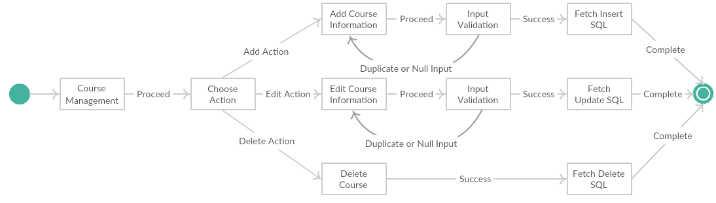

**Figure 4.4.5, State Chart Diagram of Course Management.**

In this diagram, it showed the process of course management. Admin needs to choose the course in order to take action on it. There are 3 actions in this process, which are Add, Edit and Delete.

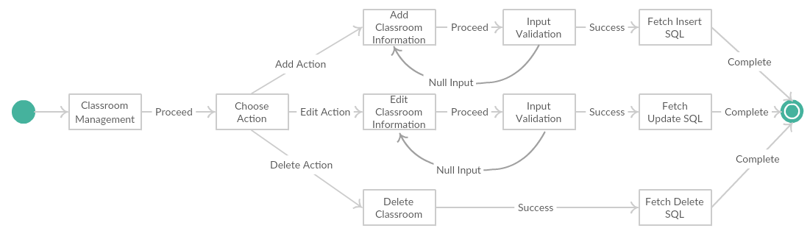

**Figure 4.4.6, State Chart Diagram of Session Management.**

In this diagram, it showed the process of session management. Admin needs to choose the session in order to take action on it. There are 3 actions in this process, which are Add, Edit and Delete.

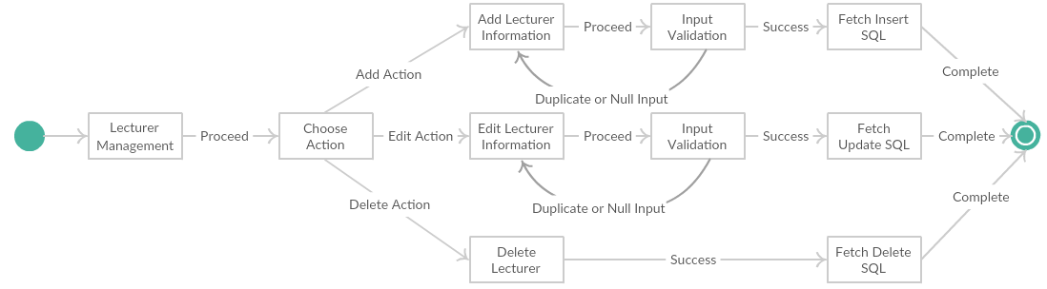

**Figure 4.4.7, State Chart Diagram of Lecturer Management.**

In this diagram, it showed the process of lecturer management. Admin needs to choose the lecturer in order to take action on it. There are 3 actions in this process, which are Add, Edit and Delete.

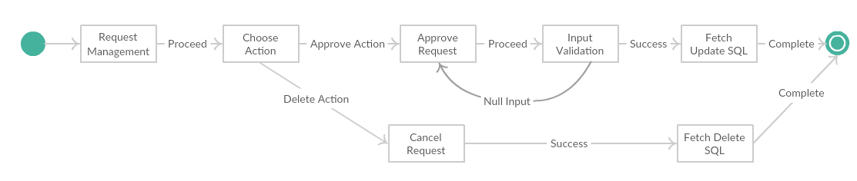

**Figure 4.4.8, State Chart Diagram of Request Management.**

In this diagram, it showed the process of request management. Admin needs to choose the request in order to take action on it. There are 2 actions in this process, which are Edit and Delete.

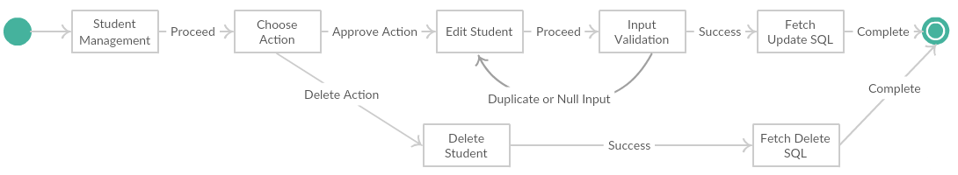

**Figure 4.4.9, State Chart Diagram of Student Management.**

In this diagram, it showed the process of student management. Admin needs to choose the student in order to take action on it. There are 2 actions in this process, which are Edit and Delete.

## 4.3 Data Dictionary

Data Dictionary is basically describing that all the information of data in a crucial library, as it provides details of all the data, such as business data, university data, government data and much more. Moreover, Data Dictionary mostly describes it as Data Definition Metrix, because it describes all the data information with very details, such as the elements of data, the value that allowable to input for particular data and the meaning and kind of use for particular data. For instance, student username, password and email from the data of IT Asia Academy, the username and password are only allowing character and number, while for the email to insert successfully then the user must input email format correctly, otherwise, it will display an error message for validation error. Furthermore, Data Dictionary is also called a database and database management system, because both of their terms are related and also provides the same information and data with details to the user. Furthermore, it is also a description of database collection and explanation in a documentation for the database. In this section, the author will describe data dictionary of the Course Registration and Management System.

**Admin**

|  |  |  |  |  |
| --- | --- | --- | --- | --- |
| **Column Name** | **Key** | **Data Type** | **Length** | **Description** |
| AID | Primary | int | 11 | No Duplicate |
| AName |  | varchar | 255 | Name of Admin |
| AUsername |  | varchar | 255 | Admin Username (No Duplicate) |
| APassword |  | varchar | 255 | Admin Password |

**Lecturer**

|  |  |  |  |  |
| --- | --- | --- | --- | --- |
| **Column Name** | **Key** | **Data Type** | **Length** | **Description** |
| LID | Primary | Int | 11 | No duplicate |
| LName |  | varchar | 255 | Name of Lecturer |
| LUsername |  | varchar | 255 | Lecturer Username (No Duplicate) |
| LPassword |  | varchar | 255 | Lecturer Password |

**Student**

|  |  |  |  |  |
| --- | --- | --- | --- | --- |
| **Column Name** | **Key** | **Data Type** | **Length** | **Description** |
| SID | Primary | int | 11 | No duplicate |
| SName |  | varchar | 255 | Name of Student |
| SUsername |  | varchar | 255 | Student Username (No Duplicate) |
| SPassword |  | varchar | 255 | Student Password |
| SEmail |  | varchar | 255 | Student Email (No Duplicate) |

**Course**

|  |  |  |  |  |
| --- | --- | --- | --- | --- |
| **Column Name** | **Key** | **Data Type** | **Length** | **Description** |
| CourseID | Primary | int | 11 | No duplicate |
| CourseName |  | varchar | 255 | Name of Course |
| CoursePrice |  | varchar | 255 | Price of Course (No Duplicate) |
| LID | Foreign Key | int | 11 | Lecturer ID (Foreign Key) |
| CourseDesc |  | varchar | 255 | Course Description |
| Session |  | varchar | 255 | Course Session |
| Hours |  | varchar | 255 | Course Hours |

**Classreservation**

|  |  |  |  |  |
| --- | --- | --- | --- | --- |
| **Column Name** | **Key** | **Data Type** | **Length** | **Description** |
| CRID | Primary | int | 11 | No duplicate |
| ClassID | Foreign Key | int | 11 | Classroom ID (Foreign Key) |
| CourseID | Foreign Key | int | 11 | Course ID (Foreign Key) |
| SID | Foreign Key | int | 11 | Student ID (Foreign Key) |
| CRDate |  | varchar | 255 | Course Reservation Date |

**Classroom**

|  |  |  |  |  |
| --- | --- | --- | --- | --- |
| **Column Name** | **Key** | **Data Type** | **Length** | **Description** |
| ClassID | Primary | int | 11 | No duplicate |
| CourseID | Foreign Key | int | 11 | Course ID (Foreign Key) |
| Slot |  | varchar | 255 | Classroom Slot |
| Capacity |  | varchar | 255 | Classroom Capacity |
| Location |  | varchar | 255 | Classroom Location |
| StartTime |  | varchar | 255 | Start time for Classroom |
| EndTime |  | varchar | 255 | End time for Classroom |
| ClassDate |  | varchar | 255 | Classroom Date |

**Orders**

|  |  |  |  |  |
| --- | --- | --- | --- | --- |
| **Column Name** | **Key** | **Data Type** | **Length** | **Description** |
| OrderID | Primary | int | 11 | No duplicate |
| ClassID | Foreign Key | int | 11 | Class ID (Foreign Key) |
| CourseID | Foreign Key | int | 11 | Course ID (Foreign Key) |
| SID | Foreign Key | int | 11 | Student ID (Foreign Key) |
| Price |  | varchar | 255 | Order Price |
| Status |  | varchar | 255 | Order Status |
| BankBranch |  | varchar | 255 | Order Bank Branch |
| PaymentDate |  | varchar | 255 | Payment Date |
| OrderDate |  | varchar | 255 | Order Date |

**Waitinglist**

|  |  |  |  |  |
| --- | --- | --- | --- | --- |
| **Column Name** | **Key** | **Data Type** | **Length** | **Description** |
| WLID | Primary | int | 11 | No duplicate |
| ClassID | Foreign Key | int | 11 | Classroom ID (Foreign Key) |
| CourseID | Foreign Key | int | 11 | Course ID (Foreign Key) |
| SID | Foreign Key | int | 11 | Student ID (Foreign Key) |
| WLDate |  | varchar | 255 | Waiting List Date |

**Attendance**

|  |  |  |  |  |
| --- | --- | --- | --- | --- |
| **Column Name** | **Key** | **Data Type** | **Length** | **Description** |
| AID | Primary | int | 11 | No duplicate |
| ClassID | Foreign Key | int | 11 | Classroom ID (Foreign Key) |
| CourseID | Foreign Key | int | 11 | Course ID (Foreign Key) |
| SID | Foreign Key | int | 11 | Student ID (Foreign Key) |
| LID | Foreign Key | int | 11 | Waiting List Date |
| CRDate |  | varchar | 255 | Class Reservation Date. To identify which date. |
| Attendance_Status |  | varchar | 255 | Attendance Status (For instance, Present or Absent) |

## 4.4 User Interface Design

In this section, the author has already drawn all the low-fidelity prototype for this course registration and management system. All the pages of header, menu and footer will look same.

**Index Page**

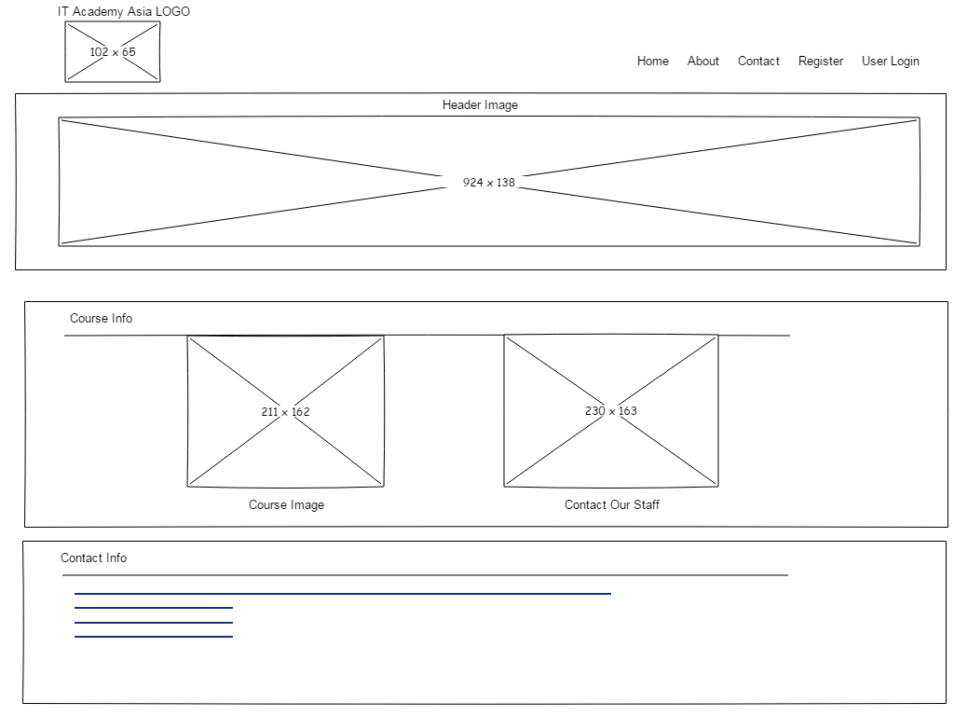

**Figure 4.5.1, Low-Fidelity Prototype of Index Page**

This is the low-fidelity prototype of the index page, the content of page consists of a header with image, course info and contact info. The index web page will be based on this low-fidelity prototype to design it.

**Contact Page**

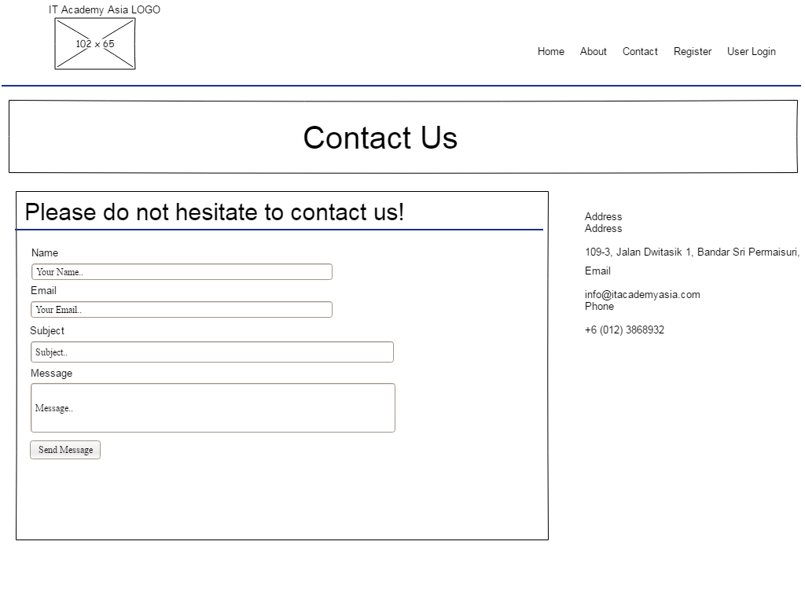

**Figure 4.5.2, Low-Fidelity Prototype of Contact Page**

This is the low-fidelity prototype of the contact page, the content of this page consists of header title name, data entry form and address & contact info. The contact web page will be based on this low-fidelity prototype to design it.

**Register Page**

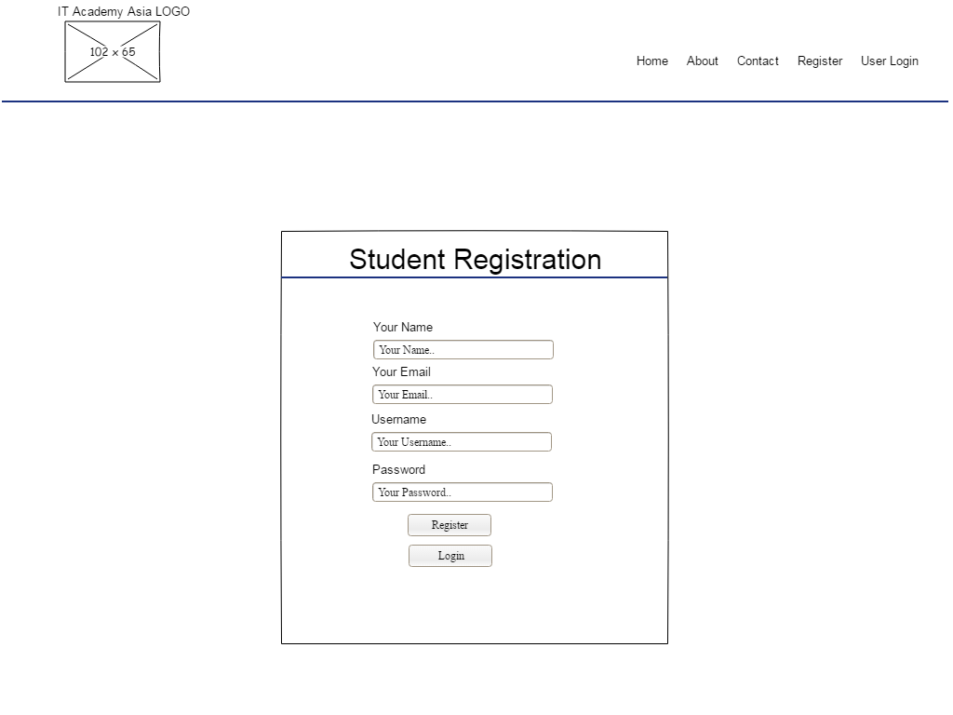

**Figure 4.5.3, Low-Fidelity Prototype of Student Register Page**

This is the low-fidelity prototype of student register page, the content of this page consist of data entry form. The student register web page will be based on this low-fidelity prototype to design it.

**Login Page**

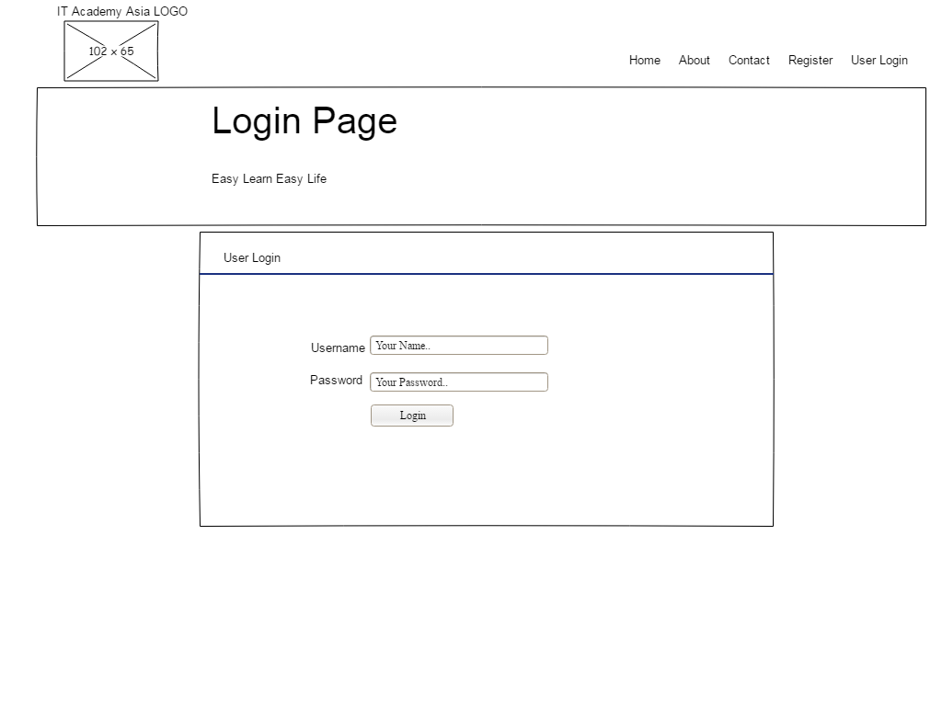

**Figure 4.5.4, Low-Fidelity Prototype of Login Page**

This is the low-fidelity prototype of the login page, the content of this page consist of header title name and data entry form. The login web page will be based on this low-fidelity prototype to design it.

**View Course Page**

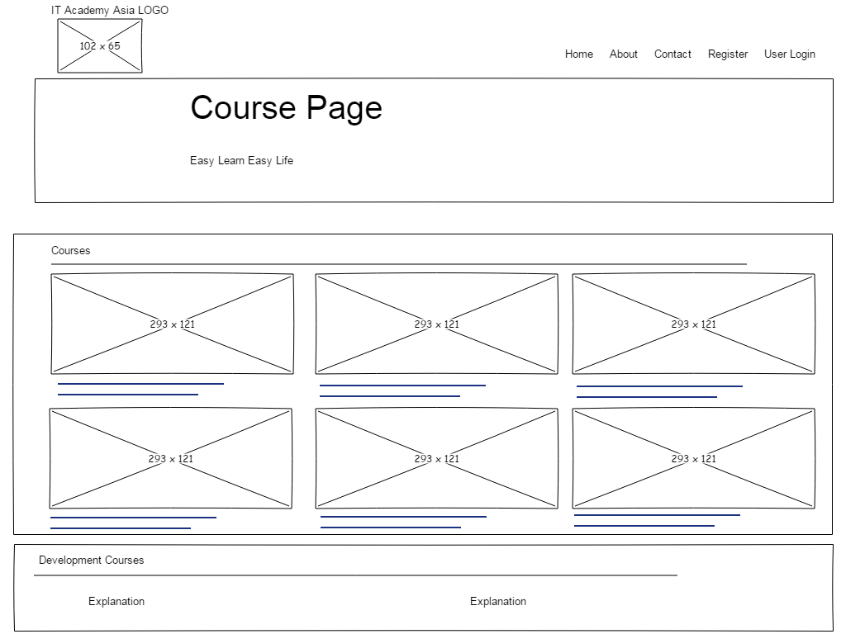

**Figure 4.5.5, Low-Fidelity Prototype of View Course Page**

This is the low-fidelity prototype of view course page, the content of this page consist of header title name and list of courses. The view course web page will be based on this low-fidelity prototype to design it.

**List View Data Page**

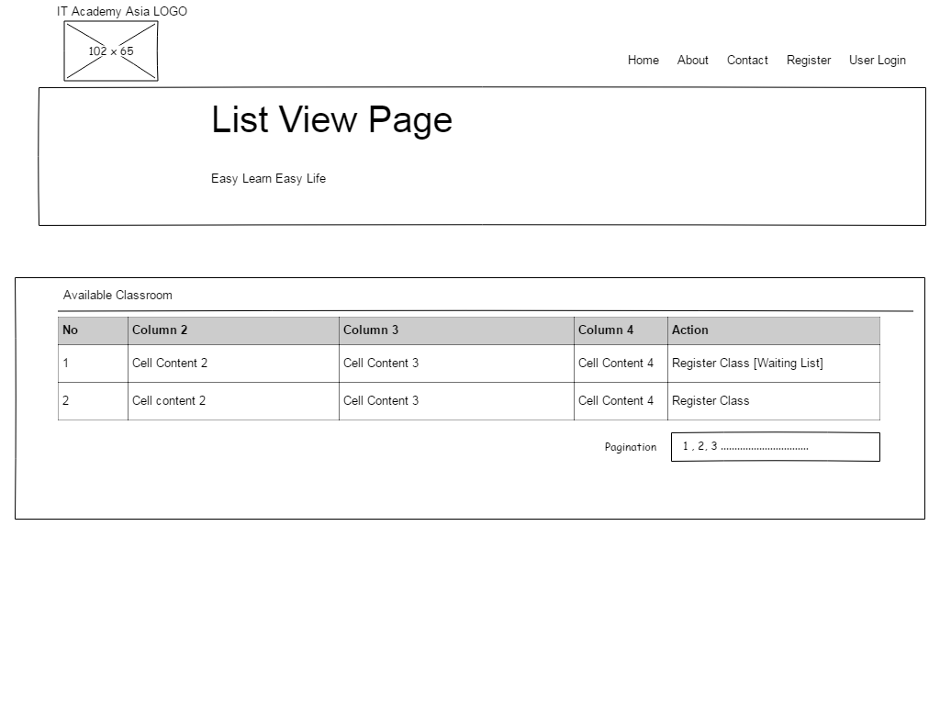

**Figure 4.5.6, Low-Fidelity Prototype of View Data Page**

This is the low-fidelity prototype of view data page, the content of this page consist of header title name and list view of data. The view data web page will be based on this low-fidelity prototype to design it.

**User Setting Page**

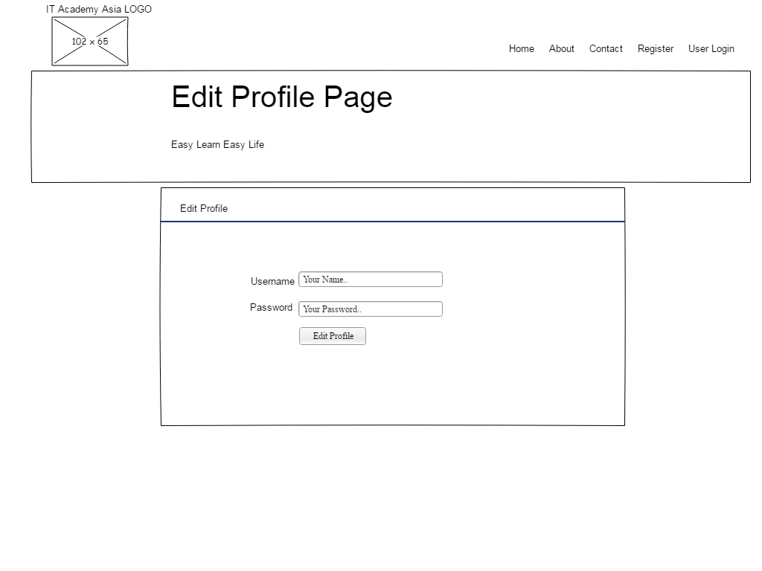

**Figure 4.5.7, Low-Fidelity Prototype of User Setting Page**

This is the low-fidelity prototype of user setting page, the content of this page consist of header title name and data entry form. The user setting web page will be based on this low-fidelity prototype to design it.

**Admin – Dashboard Page**

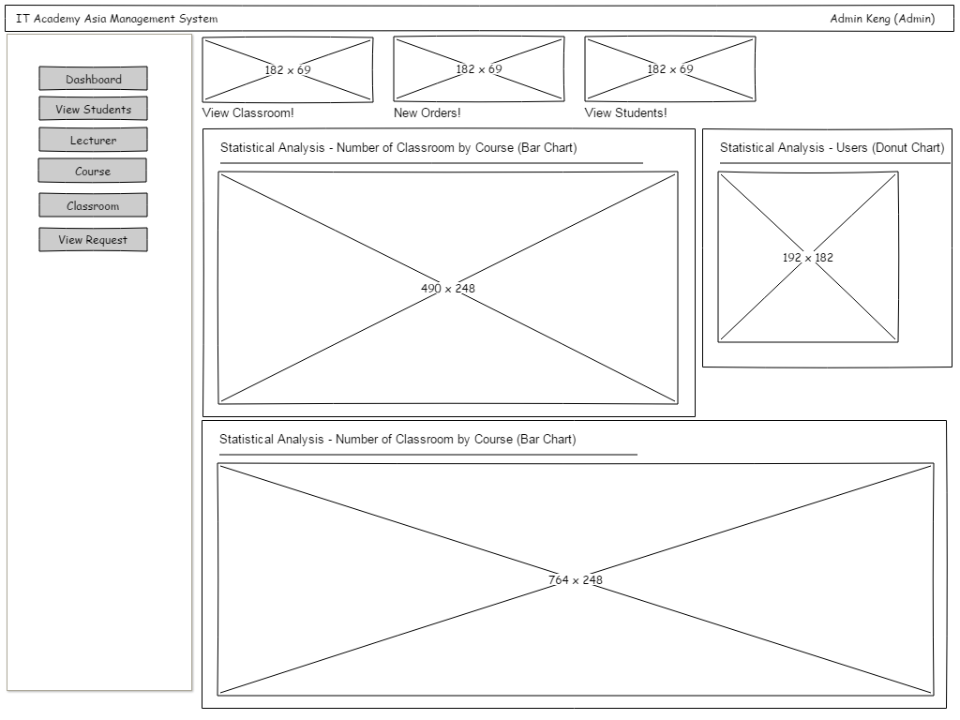

**Figure 4.5.8, Low-Fidelity Prototype of Admin Dashboard Page**

This is the low-fidelity prototype of admin dashboard page, the content of this page consist of a list of data and few statistical analysis diagrams. The admin dashboard page will be based on this low-fidelity prototype to design it.

**Admin – List View Data Page**

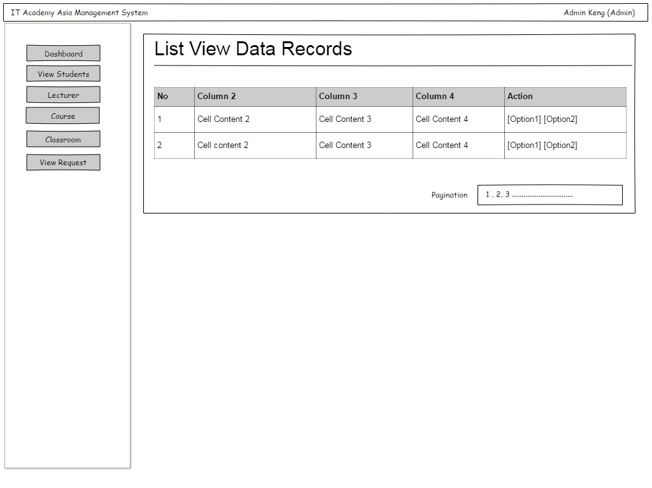

**Figure 4.5.9, Low-Fidelity Prototype of Admin List View Data Page**

This is the low-fidelity prototype of admin list view data page, the content of this page consist of the list view of data. The admin list view data page will be based on this low-fidelity prototype to design it.

**Admin – Add Form Page**

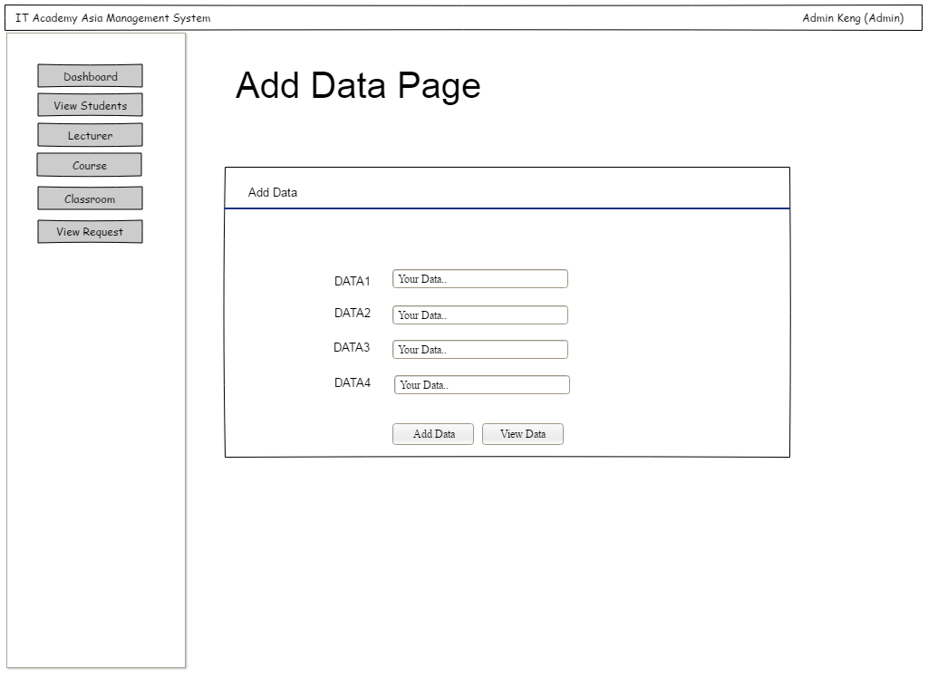

**Figure 4.5.10, Low-Fidelity Prototype of Admin Add Form Page**

This is the low-fidelity prototype of admin Add Form page, the content of this page consist of data entry form. The admin add form page will be based on this low-fidelity prototype to design it.

**Admin – Edit Form Page**

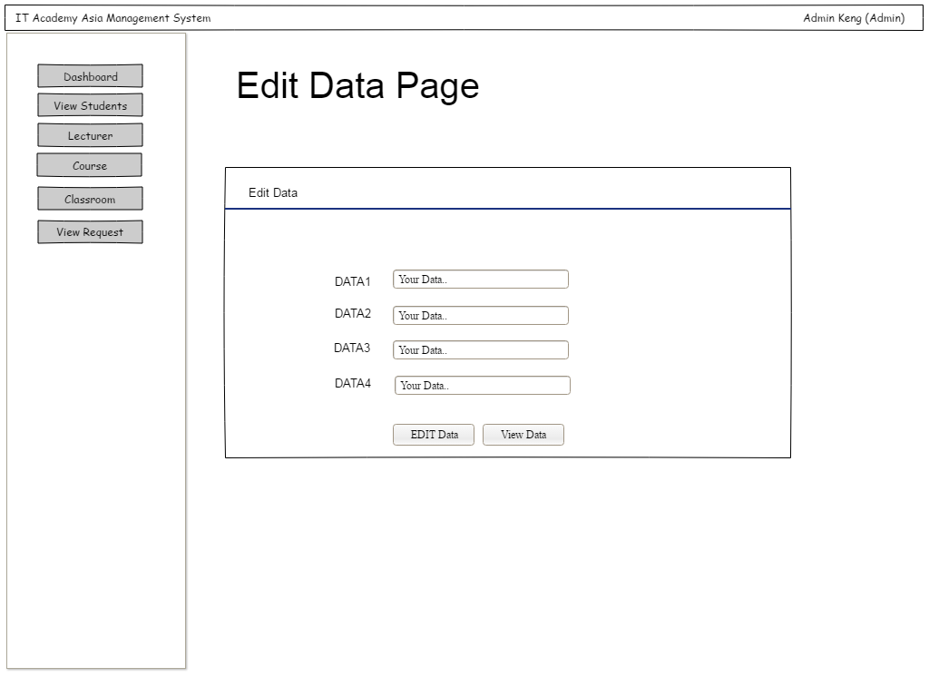

**Figure 4.5.11, Low-Fidelity Prototype of Admin Edit Form Page**

This is the low-fidelity prototype of admin Edit Form page, the content of this page consist of data entry form. The admin edit form page will be based on this low-fidelity prototype to design it.

## 4.5 Functional & Non-Functional Requirements

### Functional Requirements

1. **Student**

**Register**

* The visitor is available to register a student account. However, the visitor must correct all the validation first only can register successfully. Furthermore, if registered success then it will redirect to verification page and send them an email verification code, to ask visitor enter the verification code.

**Login**

* The student needs to login to this course registration system in order to make course registration. However, if they inputting wrong username and password it will display an error message.

**Course Registration**

* For the student to make any course registration, the student need to select a particular course first, then select an available session to register it.

**Waitlist Functional**

* When the session is not available, the student can add the session to waitlist record. Once the session is available then the system will automatically move the waitlist record into reservation session record.

1. **Lecturer**

**Record Attendance**

* The lecturer is available to record student attendance. If attendance was recorded, the lecturer can still edit the record attendance information. Furthermore, the lecturer can export the attendance record to excel file and download it.

1. **Admin**

**Data Record Management**

* The admin has an ability to manage all the data record, such as course, session, lecturer and student information. The admin is available to Create, Read, Update and Delete all the data record information.

**Order Request Management**

* The admin has an ability to approve and cancel the order request that made by the student. Once the order is approved by admin, the system will automatically send a notification receipt email to students.

### 4.5.2 Non-Functional Requirements

**Security Requirement**

* The security must implement in the course registration and management system, as the product owner doesn’t want the data to be leaked to a third-party organization. Therefore, the author has implemented advanced security to protect the MySQL Database in order to avoid someone who intends to steal or hack the data.

**Usability Requirement**

* If there are any end-users whose first time interacting with the course registration system, there will be a training session for them. Furthermore, this system is user-friendly so that it will be no any issues for end-user to use it. The end-user can easily follow up all the main functionalities.

**Performance Requirement**

* The performance of this course registration system is considered perfect, as the end-user has already tested it, to load a page only take less than 5 seconds. Therefore, it can avoid any code that runs to crash the server. The web page will take a long time to loads is because the system is sending an email to the user.

**Reliability Requirement**

* The reliability of this course registration system is high, as it can avoid the data record to be incidentally deleted. Since the relationship of database tables are connecting with each other. Therefore, it will avoid some important data record to be incidentally deleted. Other than that, it still has an ability to back up any data record that was deleted incidentally.

## 4.6 Conclusion

In the conclusion, all the analysis and design are all listed down in this chapter. There are several UML Diagram has been shown in this chapter, such as Use Case Diagram, Class Diagram and ERD Diagram. Furthermore, there are also several process design has been shown in this chapter, such as Sequence Diagram and Stated Chart Diagram. Most importantly, Data Dictionary has been shown also in order to help the author to easily design and create the database.

# 5.0 Chapter 5 – Software Testing and Outcome

## 5.1 Introduction

This is the important part after development is completed, the author will need to fully test all the functionalities and modules. There are 3 roles which are admin, lecturer and student, the author will fully test all the functionalities and modules for each of the roles. The purpose of testing is to make sure all the functionalities are achieved the expected result. Therefore, the author will be listing down all the test scenario at the following.

## 5.2 Test Script Table

|  |  |  |  |  |  |
| --- | --- | --- | --- | --- | --- |
|  | **User type** | **Test case** | **Expected Result** | **Result** | **Remarks** |
| 1 | Visitor | Send inquiry message to Contact us a message | Successfully sent an inquiry message to server mail. | Pass |  |
| 2 | Visitor | Input existed email and username in the registration form and submit. | Failed to register | Pass |  |
| 3 | Visitor | Input new email and username in the registration form and submit. | Register success | Pass |  |
| 4 | Visitor | Input email verification code to verify the student account. | Verify account success | Pass |  |
| 5 | Visitor | Input empty or wrong e verification code to verify the student account. | Failed to verify account | Pass |  |
| 6 | Student | Student Login to their account. Link them to view course page. | Login success | Pass |  |
| 7 | Student | Student login with invalid username and password. | Login failed | Pass |  |
| 8 | Student | View List of Course | Display Course in list view table | Pass |  |
| 9 | Student | View List of Session | Display Session in list view table | Pass |  |
| 10 | Student | Register course with the available Session. | Register Course Successfully | Pass |  |
| 11 | Student | Register course with not available (Full Slot) Session. | Failed to register the Course | Pass |  |
| 12 | Student | Add the course to the waiting list. | Successfully add a course to the waiting list | Pass |  |
| 13 | Student | View List of Requests. | Display Requests in list view table | Pass |  |
| 14 | Student | View Pay Info. | Display Company Information and Bank Information | Pass |  |
| 15 | Student | Cancel the Session. | Cancel Session successfully | Pass |  |
| 16 | Student | Edit Profile Information. | Edit profile information successfully | Pass |  |
| 17 | Student | View Session Schedule. | Display Session Schedule in list view table. | Pass |  |
| 18 | Student | Logout student account. | Logout student account successfully. | Pass |  |
| 19 | Lecturer | Lecturer login with their account. Redirect them to view course page. | Login successfully | Pass |  |
| 20 | Lecturer | View List of Course | Display course in list view table | Pass |  |
| 21 | Lecturer | View List of Session | Display Session in list view table | Pass |  |
| 22 | Lecturer | Record attendance in particular Session | Record attendance successfully | Pass |  |
| 23 | Lecturer | Edit Profile Information. | Edit profile information successfully | Pass |  |
| 24 | Lecturer | View Session Schedule. | Display Session schedule in list view table. | Pass |  |
| 25 | Lecturer | Logout lecturer account. | Logout lecturer account successfully. | Pass |  |
| 26 | Admin | View list of student account | Display student account in list view table | Pass |  |
| 27 | Admin | Edit student account information | Edit successfully | Pass |  |
| 28 | Admin | Delete student account | Delete successfully | Pass |  |
| 29 | Admin | View list of lecturer account | Display lecturer account in list view table | Pass |  |
| 30 | Admin | Add lecturer account | Add successfully | Pass |  |
| 31 | Admin | Edit lecturer account information | Edit successfully | Pass |  |
| 32 | Admin | Delete lecturer account | Delete successfully | Pass |  |
| 33 | Admin | View list of course account | Display course account in list view table | Pass |  |
| 34 | Admin | Add course | Add successfully | Pass |  |
| 35 | Admin | Edit course information | Edit successfully | Pass |  |
| 36 | Admin | Delete course account | Delete successfully | Pass |  |
| 37 | Admin | View list of Session | Display Session in list view table | Pass |  |
| 38 | Admin | Add Session | Add successfully | Pass |  |
| 39 | Admin | Edit Session information | Edit successfully | Pass |  |
| 40 | Admin | Delete Session | Delete successfully | Pass |  |
| 41 | Admin | View list of request | Display request in list view table | Pass |  |
| 42 | Admin | Approve request order | Approve successfully | Pass |  |
| 43 | Admin | Cancel request | Cancel successfully | Pass |  |
| 44 | Admin | View Dashboard | Display data record number of students, requests and courses. | Pass |  |
| 45 | Admin | View Dashboard | Display Statistical Analysis Diagram (Pie Chart, Line Chart) | Pass |  |
| 46 | Admin | Edit Profile Information. | Edit profile information successfully | Pass |  |
| 47 | Admin | Logout student account. | Logout Admin account successfully. | Pass |  |

## 5.3 Conclusion

The conclusion of chapter 5, the author has finally tested 47 test scenarios. Fortunately, all these 47 test scenarios are all passed. Furthermore, there are no any remarks for each of these test scenarios, as the functionalities were implemented nicely.

# **6.0 Chapter 6 – Implementation and Evaluation**

## 6.1 Introduction

In this chapter, the author will be discussing the on implementation and evaluation. In the implementation and evaluation, there are few parts to be discussed. The first part will be discussing the functionality achievement, in this part, it will be including all the functionality that is completely implemented and with a description of each function. The second part will be discussing on system modules and function, in this part, it will be including all the system modules with an explanation. The third part will be discussing on bugs and input validation, all the errors and bugs will be listed down with an explanation. The fourth part will be discussed in the user manual, for this part, all the screenshot and demonstration will be shown in Appendix C. The fifth part is to discuss advantage and disadvantage of this system.

## 6.2 Functionality Achievement

**Register**

The visitor is available to register a student account in order to log in to the system. However, they must pass all the validations, such as Username, Password, Name and Email. Furthermore, if registered success then it will redirect to verification page and send them an email verification code, to ask visitor enter the verification code. Besides, they can request for resending the email verification code. Other than that, the system also provided a way to let visitor change their email if they incidentally inputting the wrong email.

**Login**

The student needs to login to their account in order to make any course registration. However, if they inputting wrong username and password it will display an error message. Furthermore, if student account is not yet activated, it will redirect to verification page and send them an email verification code, to ask student enter the verification code. Besides, they can request for resending the email verification code. Other than that, the system also provided a way to let visitor change their email if they incidentally inputting the wrong email.

**Course Registration**

The author has finally achieved to implemented this course registration module. For the student to make any course registration, the student need to select a particular course first, then select an available session to register it. Other than that, if the session is not available, the student can add the session to waitlist record. Besides, it still allows students to view the pay info (Company and bank information), and also cancel the session. Students and lecturers are available to view the session timetable.

**Record Attendance**

The author has achieved to implemented this record attendance module. The lecturer is available to record student attendance by selecting particular course and session. If the lecturer has already recorded an attendance, the lecturer can only edit the record attendance information. Furthermore, the lecturer can export the record attendance into excel file and download it.

**Data Record Management**

All the data record management are fully implemented, such as course, session, lecturer and student information. The admin is available to Create, Read, Update and Delete all the data record information. However, there are still some bugs and validation error to fix in future, such as no limitation inputting the data fields.

**Order Request Management**

The order request management module is achieved to implement it. The admin is available to approve and cancel the order request. Once the order is approved by admin, the system will automatically send a notification receipt email to students. Therefore, the student can keep it as evidence.

## 6.3 System modules and functions explanation

|  |  |  |  |
| --- | --- | --- | --- |
|  | System Module | Explanation | User type |
| 1 | Student Registration  Modules | Visitor in this system can register a student account, then only they can reserve a session. | Visitor |
| 2 | Send Inquiry Message Modules | The visitor can send inquiry email message to this server email. | Visitor |
| 3 | Login  Modules | This system has 3 types of login modules which are Admin, Lecturer and Student. | Admin, Lecturer and Student |
| 4 | Edit Profile Information | This system is available for any users to edit their information, such as a password. | Admin, Lecturer and Student |
| 5 | Make Course Registration Modules | A student can make a course registration and select their session with a particular date which provided by the course. | Student |
| 6 | Cancel Course Registration Modules | The student is available to cancel the session for a particular course. Once payment is made student cannot cancel anymore. | Student |
| 7 | View Session Schedules Modules | Student and Lecturer are available to view their session timetable. | Student and Lecturer |
| 8 | Record Attendance Modules | The lecturer can record attendance for a particular session by selecting a particular course. | Lecturer |
| 9 | Course Management Modules | Admin is available to Create, Read, Update and Delete the course information record from a database table. | Admin |
| 10 | Session Management Modules | Admin is available to Create, Read, Update and Delete the session information record from a database table. | Admin |
| 11 | Lecturer Management Modules | Admin is available to Create, Read, Update and Delete the lecturer account information record from a database table. | Admin |
| 12 | Student Management Modules | Admin is available to Read, Update and Delete the course student account information record from a database table. | Admin |
| 13 | Request Management Modules | Admin is available to set Approve and Cancel the order request information record from a database table. | Admin |
| 14 | View Dashboard Modules | Admin able to access a dashboard page and is available to view all the data analysis and statistical analysis diagram, such as pie chart, line chart and bar chart. | Admin |

## 6.4 Bugs and Input Validation

There are some bugs in the Course Registration and Management System. The author will be explaining each of the bugs at the following.

* For the student registration, there is no word limit for a student to input it. However, if someone intends on do unethical behaviour like inputting nonsense information, the system still easy to be breaking into.
* For the inquiry mail that sends to our server mail, there no limitation for sending an inquiry message to server mail. However, if someone has an intention to attack our system, they can just simply use some bot scripted tool to send mail to our server.
* In the index page, there is too much content, which means that user has to scroll down to read other details.
* In admin management system, admin can be inputting any character without limitation, sometimes will cause them to mistakenly input nonsense information.

## 6.5 User Manual (User Guide)

User Manual will be shown in Appendix Section, please go refer it to Appendix C – User Manual (Click the link).

## 6.6 Advantage and Disadvantages of Course Registration System

### 6.6.1 Advantage of this course registration system

**Register Email Verification - Security**

In this system, it has an ability to make sure student inputting a valid and real email while registering their account, which called email verification. Therefore, the system can send any notification mail to their email address without any errors.

**Course Registration**

In this system, it has an ability to let students make course registration conveniently. Students are available to view a list of courses in a product list with the price shown there. After selecting for a particular course, redirect them to session page to register the available session. However, if the session is not available, students can add the session to the waiting list. Therefore, when someone cancels the session, students will have the opportunity to queue for it to register session that is preferred. Besides, it seems to be so systematic, as it provides step by step method for the student to register course.

**Student Attendance Record**

In this system, it has an ability to let lecturer record student attendance conveniently. Lecturers are available to view a list of courses and choose the course, after choosing the course it will redirect to session page. Therefore, lecturers can choose any session that available in the course to make student attendance record.

**Admin Management System**

In this system, it provides management modules for admin to manage all the data record flexibly. Admin is available to manage information of course, session, lecturer and student. Moreover, these admin management modules are implemented for avoiding staff using Microsoft Excel to recording all the data and information as well as paperwork.

**View Dashboard**

In this system, it provides a dashboard for admin to view the variety of statistical analysis diagrams in order to let them read the data and do the data analysis.

### 6.6.2 Disadvantage of this course registration system

**Security of Payment Gateway is not that perfect**

Although there is a payment gateway implemented in this project, it cannot be instant purchase like using other payment method API, such as Paypal, iPay88 and more. It will store the order request in a temporary database table, the student needs to bank in the money into company bank account and screenshot as evidence then sends to company email, once company received the evidence only admin will approve student’s order request. However, the author is going to implement Paypal payment method into this system, as this system is just stimulation and prototype version.

**Some validation errors**

Although the system is fully implemented all the fields for inserting data record, there are some validation errors not yet complete, such as no limitation character while inputting the fields. This issues may cause user inputting nonsense information into the database which causing trouble in the database. However, the author is going to fix this bugs, as this system is stimulation and prototype version.

## 6.7 Conclusion

Finally, it is the conclusion of chapter 6, the parts of functionality achievement, system modules and functions explanation, bugs and input validation, user manual, advantage and disadvantage of this course registration are already listed down and shown with all the explanation.

# **7.0 Chapter 7 – Conclusion**

## 7.1 Assessment of the final product

The purpose for the author to develop and enhance this “Course Registration and Management System” is to help the IT Academy Asia company to solve their current issues and problems. Therefore, in this enhanced system, their staff is available to manage all the data record, such as the information of users account, courses, session and order request. Moreover, this enhanced system has an ability to let the student make course registration conveniently and flexible. For example, the student can search for their session with a preferred time. However, if a session is not available, the student is available to add the session to the waiting list for queuing someone cancels the session. Furthermore, there is an email verification implemented in this system in order to make sure student is inputting their real email. Therefore, the system can send any notification receipt email to the student without any errors. Moreover, this system also helps lecturer to record student attendance in order to avoid them from using Microsoft Excel as well as paperwork to do their works. In the overall, although the system is not that perfect, it meets all the requirement from the end-user.

## 7.2 Critically access

The critical assessment of the “IT Academy Asia Old System” is that the system cannot provides a way to let students make course registration conveniently. Furthermore, the old system doesn’t provide the student to login to their account to view session timetable and view their current order request. Moreover, lecturer doesn’t have a function to let them make attendance record in the system. Therefore, lecturer needs to manually key in the data record into Microsoft Excel as well as paperwork. Besides, there is no admin account to access dashboard and data management for staff to utilize it. That is why the author has given them the ideas and help them to implement all these modules and functionalities into their system in order to bring more advantage to their business. Other than that, it also takes an advantage for their company, as nowadays everyone is using the internet. Therefore, there is no point to worry about a student cannot access the internet issues.

## 7.3 Personal analysis of the project experiences

After the author has successfully to get this project from IT Academy Asia company. The author comes up with many ideas that are preparing to implement all these modules into the enhancement project. The author then will have a meeting with their staff to discuss what needs to be implemented in the system. The author has given a ton of ideas to the staff and the staff was very happy with the ideas. After everything is settled, the author used 2 or 3 weeks in researching all the materials and studies which are related to “Course Registration and Management System”. Then the author starts to research for more than 5 similar products to do a comparison and then used those ideas into these project. During the time, the author had really learnt a lot from research something. After partially completed the system, the author has some meeting minutes with Ms. Kumatha, and she has given more suggestion on the documentation and also asked to fix few of the analysis diagrams. During the time while implementing the system, the author has learnt a lot of PHP programmings, such as Object-Oriented, PHP Mailer and more. Moreover, the author has also learnt how to use the Bootstrap HTML Library in order to design a nice website.

## 7.4 Future Plan

For the future plan, the author will consider discussing with a staff of IT Academy Asia to implementing new modules like student earning a point for purchasing more courses. Therefore, they can get more benefits by earning the point. Other than that, the author will have to fix all the validation errors, such as no limitation inputting the field. Moreover, the author will try to implement an advanced search data in the future enhancement. Besides, soon the author will be implementing a way to avoid visitor spamming the inquiry email to the server email as unethical behaviour.

# Harvard Reference

1. Development of Online Student Course Registration System | Oriental Journal of Computer Science and Technology. 2018. Development of Online Student Course Registration System | Oriental Journal of Computer Science and Technology. [ONLINE] Available at: <http://www.computerscijournal.org/vol9no2/development-of-online-student-course-registration-system/>. [Accessed 20 April 2018].
2. Louis-Marie Ngamassi Tchouakeu. 2012. On-line Course Registration Systems Usability. [ONLINE] Available at:

<https://pdfs.semanticscholar.org/54df/3704ae03b3f1fc472b6ad9c307627d02fe5a.pdf>. [Accessed 20 April 2018].

1. LOS ANGELES COMMUNITY COLLEGE. 2017. WAIT LIST PART OF NEW SIS (Student Information System). [ONLINE] Available at: <http://www.wlac.edu/WLAC/media/documents/new-sis/WaitList.pdf>. [Accessed 20 April 2018].
2. Top 10 advantages of automated student attendance system | Creatrix Campus. 2018. Top 10 advantages of automated student attendance system | Creatrix Campus. [ONLINE] Available at: <https://www.creatrixcampus.com/blog/top-10-advantages-automated-student-attendance-system>. [Accessed 20 April 2018].
3. YILIN LI. 2017. Add-on Course Registration System. [ONLINE] Available at: <https://digitalcommons.wou.edu/cgi/viewcontent.cgi?article=1000&context=computerscience_studentpubs>. [Accessed 20 April 2018].
4. UKEssays. 2018. Online Course Registration And Management System. [ONLINE] Available at: <https://www.ukessays.com/essays/computer-science/online-course-registration-and-management-system-computer-science-essay.php>. [Accessed 20 April 2018].
5. SearchOracle. 2018. What is MySQL? - Definition from WhatIs.com. [ONLINE] Available at: <https://searchoracle.techtarget.com/definition/MySQL>. [Accessed 20 April 2018].
6. www.guru99.com. 2018. No page title. [ONLINE] Available at: <https://www.guru99.com/what-is-php-first-php-program.html>. [Accessed 20 April 2018].
7. Ross Shannon. 2018. What is HTML? | HyperText Markup Language explained. [ONLINE] Available at: <http://www.yourhtmlsource.com/starthere/whatishtml.html>. [Accessed 20 April 2018].
8. MakeUseOf. 2018. What Is JavaScript and How Does It Work?. [ONLINE] Available at: <https://www.makeuseof.com/tag/what-is-javascript/>. [Accessed 20 April 2018].
9. TurboFuture. 2018. A Beginners Guide to Notepad++ | TurboFuture. [ONLINE] Available at: <https://turbofuture.com/computers/A-Complete-Beginners-Guide-to-Notepad>. [Accessed 20 April 2018].
10. Techopedia.com. 2018. What is Microsoft Office? - Definition from Techopedia. [ONLINE] Available at: <https://www.techopedia.com/definition/20737/microsoft-office>. [Accessed 20 April 2018].
11. Airbrake Blog. 2018. Waterfall Model: What Is It and When Should You Use It?. [ONLINE] Available at: <https://airbrake.io/blog/sdlc/waterfall-model>. [Accessed 20 April 2018].
12. 9 Steps to Launch Your First Survey (Text Tutorial) | Tutorials | VerticalResponse How To Do Everything. 2018. 9 Steps to Launch Your First Survey (Text Tutorial) | Tutorials | VerticalResponse How To Do Everything. [ONLINE] Available at: <https://help.verticalresponse.com/how-to/tutorial/9_steps_to_launch_your_first_survey/>. [Accessed 20 April 2018].

# Appendix A

**Initial proposal of Course Registration and Management System**

**Undergraduate Final Year Project Proposal**

**Course Registration and Management System for IT Academy Asia Company**

**Teoh Keng Wei**

**Bachelor in Computing**

**000963464**

**+6012-6054915**

**kengwei91@hotmail.com**

**Ms. Kumatha**

## Overview

The IT Academy Asia Kuala Lumpur is an academy which provides a high standard quality to help people who are willing to learn programming and IT related and to make their student as a professional programmer and professional in any IT field. Their objective is to teach people to improve and enhance their programming skill sets and become the most sought employee in this programming environment, in today knowledge economy. However, this company currently using their system to record data into MS Excel and use it to maintain their record, it cannot share the data from the different system, this might be giving a chance to cause mistake because of too many duplicate works. In other words, the author will be developing a fresh new system which is based-on The IT Academy Asia Kuala Lumpur condition to design and develop a proper function for their client to register and reserve a programming course’s session. This academy provides a variety of courses, such as Java, C#, C++, Ruby, Python, PHP, MySQL and Microsoft Office. Different courses have different prices and times, and some course may take two to three days to finish it.

Furthermore, the author will also provide a new function that gives convenient way for the lecturer to view and record the attendance. Therefore, the lecturer can use this web system to record attendance anytime without paperwork. Furthermore, this attendance record function helps lecturer to save more time as well as avoid produce chance of making false attendance record. Moreover, admin in this system is able to view the dashboard, such as a number of student, trainer, and session. In the summary, the author will develop a completely new system for IT Academy Asia Company, which provides a lot of flexible and convenient features for their users, it gives all different users such as admin has a good feature to manage their information and student has a convenient way in register their course.

Lastly, if the session is full, students do not have to manually check if someone cancels the session on the session page. They can just simply use the function called “wait-listing” to wait for someone to cancel the session so that the student has a priority for waiting their preferred session. Furthermore, this new system avoids human error and keeping the system workflow become more smooth.

## Aim

The aim for this project is to develop a new system for IT Academy Asia that provides a convenient and easy function for the student to register their session, before the registration of the session the system will show the duration of each course. In order to convenient the student and admin, the system added a special function implement in the reservation function called “wish listing”.

## Objectives

**3.1 To help IT Academy Asia Company to upgrade and enhance their existing course registration system, to let client effectively and with a convenient way to register a course.**

- For the previous function of their system, their client just able to send the inquiry to wait for the employee to reply them without a login function and with a bank account details to ask for bank transfer. Now the academy asked to enhance the system that client must register an account before they register a course and once course registered the system will automatically send payment information and invoice to the client.

**3.2 To create a new function in an existing system which provides admin to view the dashboard, implement CRUD functionality (Create, Read, Update and Delete) to let admin manage client and trainer information.**

- This new system will provide admin to managing the client and trainer information. In order that client or trainer requested admin to change their information, admin can easily use the function which provided the new system that helps admin manage user’s information.

**3.3 To create a new function in an existing system which help the admin/employee to view the course’s** session **and also implement the CRUD functionality which also helps the admin to manage the course’s session** **and assign a trainer to the course’s session.**

**-** Using this new enhancement system, admin no need to bother about managing the course’s session and can easily assign a trainer to a session with flexibility.

**3.4 To create a new function in an existing system which help trainer and client to view the timetable, and trainer has a function that is to record the attendance list.**

- With this new system, the client and trainer no need to wait for the academy’s employee to send them the timetable via e-mail, they can just simply view their timetable after they log in their account. Furthermore, this new system provides a function that gives the trainer to record the attendance list.

**3.5 To create a new function in an existing system which call wait-listing.**

- When a session is not available or full, the client still able to register the course’s session until someone cancels the session.

## Legal, Social, Ethical, and Professional

This system is design and developed for admin and users who are client of “The IT Academy Asia”, this project’s system not require authorization at all, as long as they are employee and client of the academy, before client reserve the course they have to make sure their age is over 18 years old to make sure there are no underage client involved in our survey for gathering and testing. By doing requirements gathering it has to get a permission from the Research Ethics Committee.

The students need to fill in their address, IC number, but they no need to provide any others privacy information, so that it can avoid any social issues.

About the professional part, it will be based on the consideration of BCS and IEEE levels. To prove this project is acceptable will do a good planning and managing.

## Planning (Refer to Schedule of Work)

About the planning part, the time estimate to complete this project need take around 5 months. In order to successfully complete the project, the author decided to minimize the risk of failure of the project to successfully follow up the deadline. To reduce the risk of failure, the Gantt chart is the best option for avoid, it uses to adjust the length of the project and also monitoring the plan.

## Initial Reference

1. Code of conduct | Membership | BCS - The Chartered Institute for IT. 2017. Code of conduct | Membership | BCS - The Chartered Institute for IT. [ONLINE] Available at: <http://www.bcs.org/category/6030>. [Accessed 17 September 2017].
2. IEEE - Publications. 2017. IEEE - Publications. [ONLINE] Available at: <http://www.ieee.org/publications_standards/index.html>. [Accessed 17 September 2017].
3. UKEssays. 2017. Legal social ethical and professional issues. [ONLINE] Available at: <https://www.ukessays.com/essays/information-technology/legal-social-ethical-and-professional-issues-information-technology-essay.php>. [Accessed 17 September 2017].
4. Project Smart. 2017. SMART Goals. [ONLINE] Available at: <https://www.projectsmart.co.uk/smart-goals.php>. [Accessed 17 September 2017].
5. BookingLive®. 2017. Open Source Booking System | Open Source Reservation System. [ONLINE] Available at: <https://www.bookinglive.com/blog/wordpress-content-management-booking-system-in-one/>. [Accessed 17 September 2017].
6. GitHub. 2017. GitHub - olejon/phpmyreservation: Web-based reservation and booking system. [ONLINE] Available at: <https://github.com/olejon/phpmyreservation>. [Accessed 17 September 2017].

## Schedule of Work

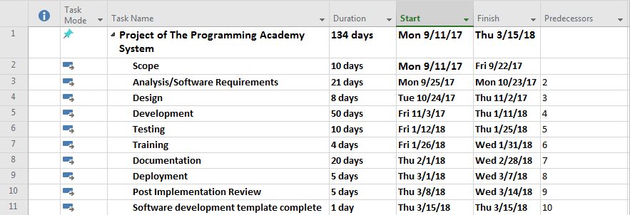

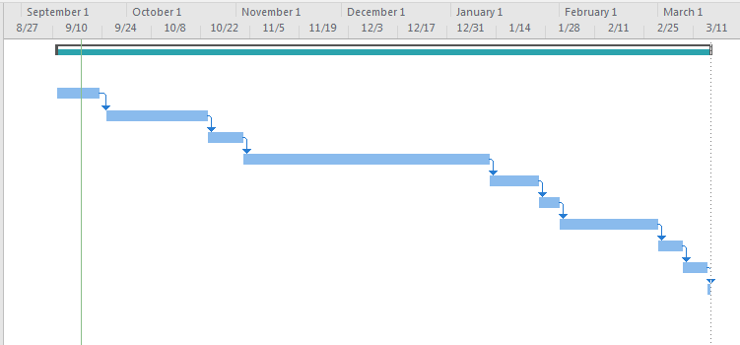

# Appendix B – Survey

**Survey Questionnaire**

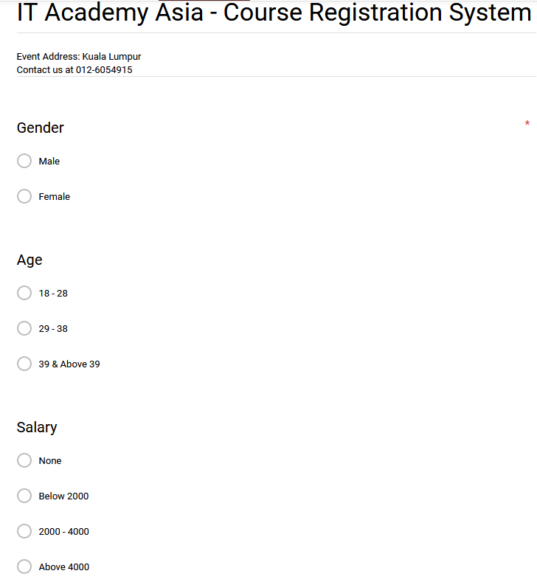

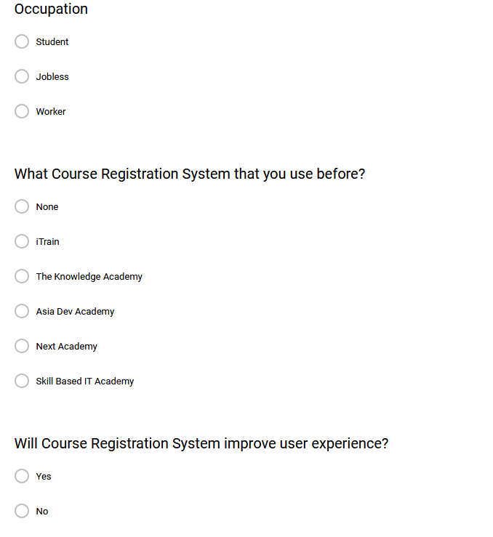

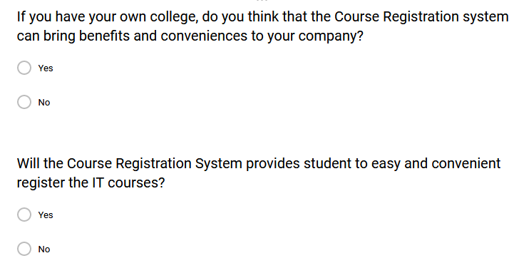

**Questionnaire Responses - Graph Statistical**

|  |
| --- |
|  |

Figure 1.0, in these graph statistical shown 30 respondents is 26.70% female respondents, while 73.3% are male respondents.

|  |
| --- |
|  |

Figure 1.1, in these graph statistical shown 46.70 % of 30 respondents’ age are 18 - 28, 36.70% of 30 respondents’ age are 29 – 38 and 16.70% of 30 respondents’ age are 39 and above 39.

|  |
| --- |
|  |

Figure 1.2, in this graph statistical it showed the result of respondents’ result, there are 13.30% selected none, 30% selected below RM 2000, 33.30% selected RM 2000 – RM 4000 and 23.30% selected above RM 4000.

|  |
| --- |
|  |

Figure 1.3, in this graph statistical shown the result of respondents’ occupation, there are 40% selected student, 10% selected jobless and 40% selected worker.

|  |
| --- |
|  |

Figure 1.4, in this graph statistical shown the result of what course registration system that student has used before, there are 13.30% selected none, 23.30% selected iTrain, 13.30% selected The Knowledge Academy, 16.70% selected Asia Dev Academy, 10% selected Next Academy and 23.30% selected Skill Based IT Academy.

|  |
| --- |
|  |

Figure 1.5, in this graph statistical shown the result of course registration system improves user experience, the accepted result was expected more than rejected.

|  |
| --- |
|  |

Figure 1.6, in this graph statistical shown the result of course registration system brings benefits and conveniences to the company, the accepted result was expected more than rejected.

|  |
| --- |
|  |

Figure 1.7, in this graph statistical shown the result of course registration system provides student easy and convenient to register courses, the accepted result was expected more than rejected.

# Appendix C – User Manual

## 1.0 Student Functionalities

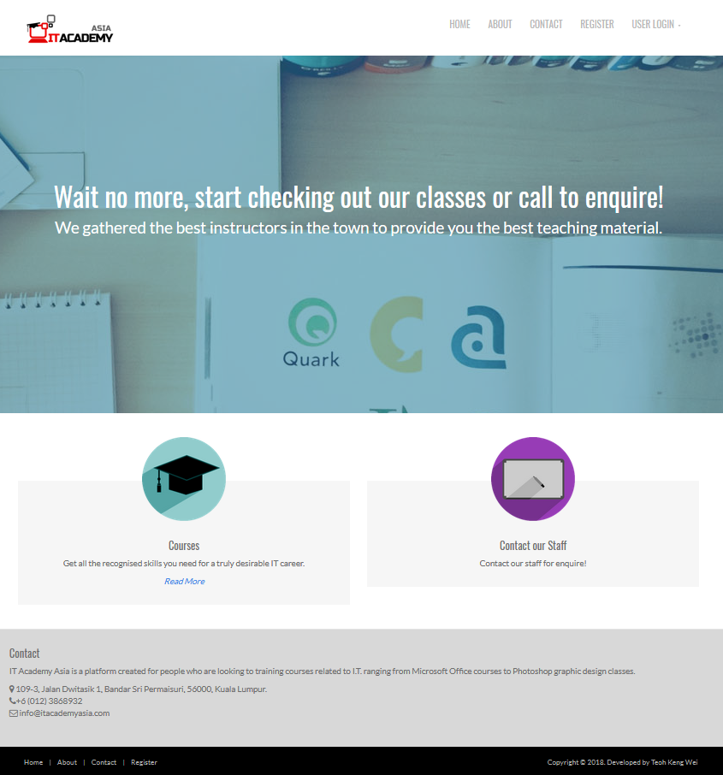

**Figure 1.0 index page – Course Registration System**

In this figure, it is index page also known as the home page of Course Registration System. In this page, it shows the users about some information that related to this IT Asia Academy. All users with different roles can access this index page, even a user that without any member.

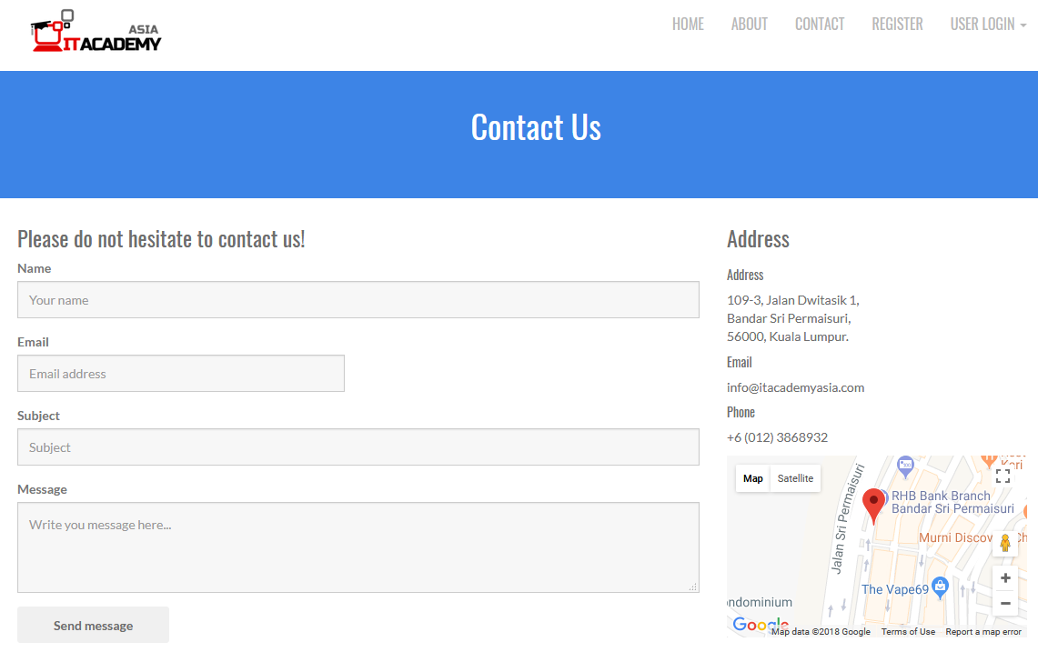

**Figure 1.0.1 Contact Us page – Course Registration System**

1. If visitor click Send Message button with fill in all the details, it will display the message ‘send successfully’.

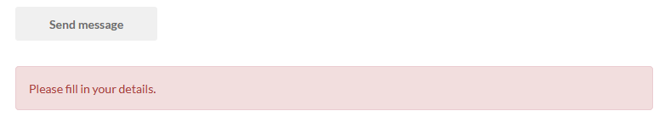

**Figure 1.0.1.1 Contact Us page – Error Message**

If visitor click Send Message button without fill in the details, it will display this error message.

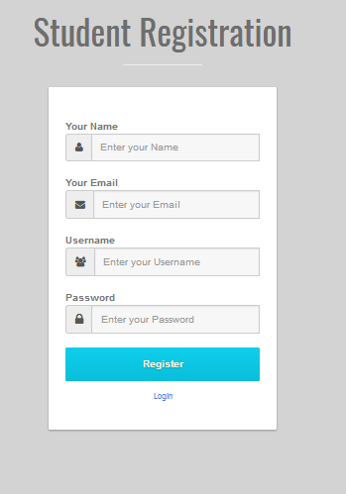

**Figure 1.1 Register Page – Course Registration System**

For this figure, it is a register page that provides for the user to register a student account in order to view the course and available session. If all the validations are correct, then it will redirect student to email verification page. The email verification code will be sent to the student’s email.

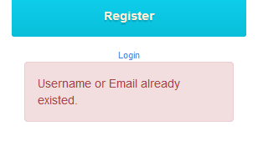 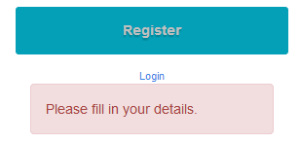

**Figure 1.1.1 Register Page – Error Message**

1. The user needs to fill in all their information if not it will display error, such as validation.
2. Furthermore, if some users insert a username that already exists in the database it will display an error message. For instance, “Sorry! The username you insert already existed!”.

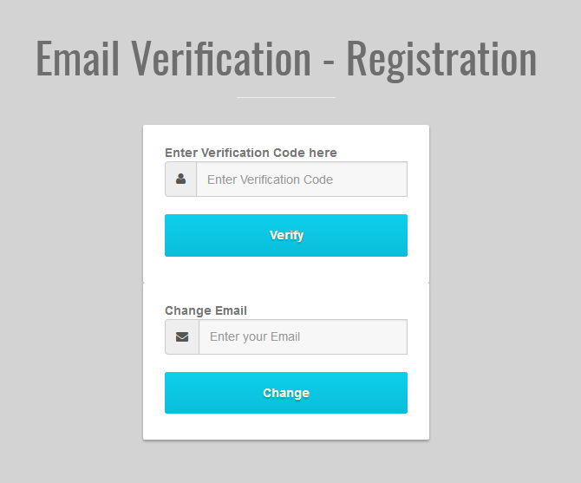

**Figure 1.2 Email Verification Page**

1. Once the student received an email verification code, input the correct verification code to verify their account, it will automatically redirect them to view course page.
2. If a student previously inputted the wrong email while registering the account, the student can change their email by inputting a new email there and click change button, the system will send new email verification.

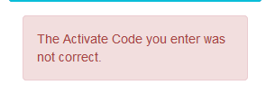 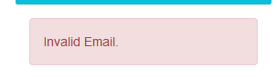

**Figure 1.2.1 Email Verification Page – Error Message**

1. If student inputted incorrect verification code, then this message will be displayed.
2. If student inputted incorrect email, then this message will be displayed.

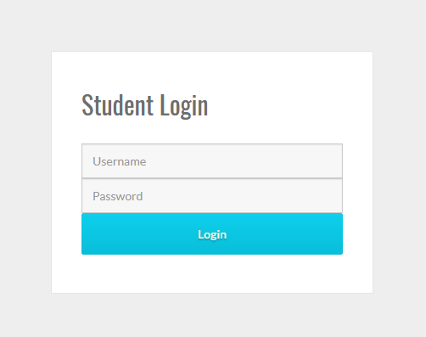

**Figure 1.3 Student Login Page**

If student inputted correct username and password, then it will successfully login to the system and redirect to view course page. However, if student account is not yet verifying, the system will redirect them to email verification page.

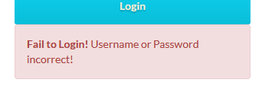

**Figure 1.3.1 Student Login Page – Error Message**

If student inputted incorrect username and password, then this error message will be displayed.

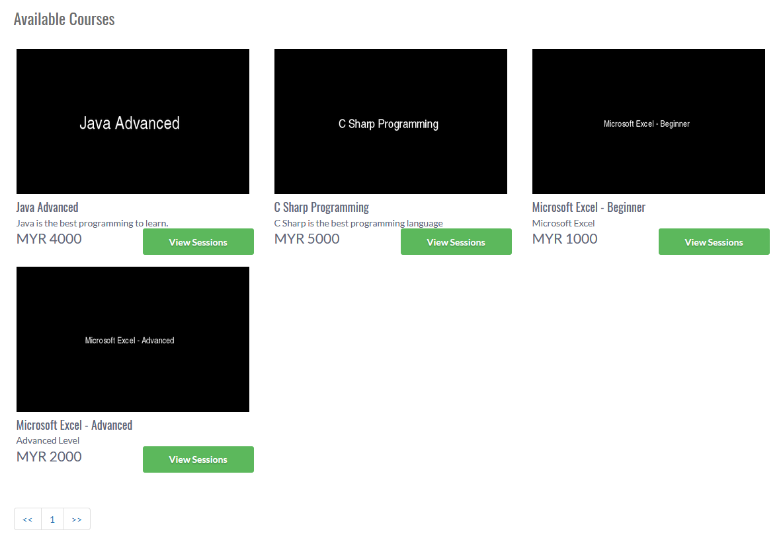

**Figure 1.4 View Course Page**

1. If a student wants to check available session from a particular course, click the ‘View Sessions’ button, it will redirect student to view session page.
2. However, there are only 6 courses in per page. If there are more than 6 courses, it will be more pages display. Therefore, if a student wants to view the second page, they can click the pagination.

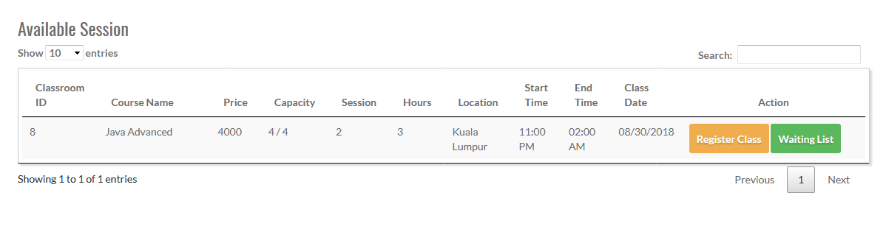

**Figure 1.5 View Session Page**

There are search and pagination function for this list view data. However, it will not be displaying any data record with an expired session date.

Once student click ‘Register Class’ button, it will display successfully register message and redirect to view request page.

1. If the session is not available, once student click this it will add this session to waitlist record and redirect to view waitlist page.

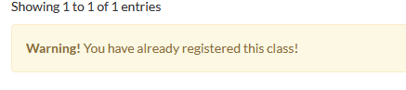

**Figure 1.5.1 View Session Page – Error Message**

If a student has been registered the session or added to waiting list record. This error message will be displayed.

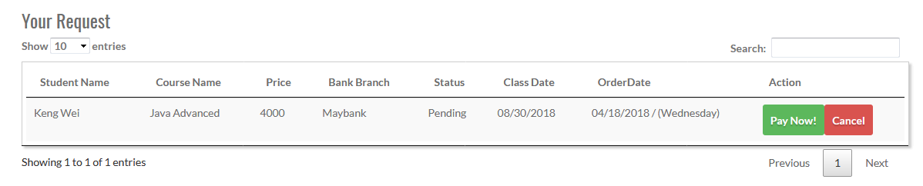

**Figure 1.6 View Request Page**

There are search and pagination function for this list view data. However, it will not be displaying any data record with an expired session date.

1. Once student click ‘Pay Now’ button, it will redirect to payment details page. Please refer to Figure 1.6.1 View Request Page – Redirect to Pay Info Page.
2. If the student clicks ‘Cancel’ button, it will delete the request record from the database.

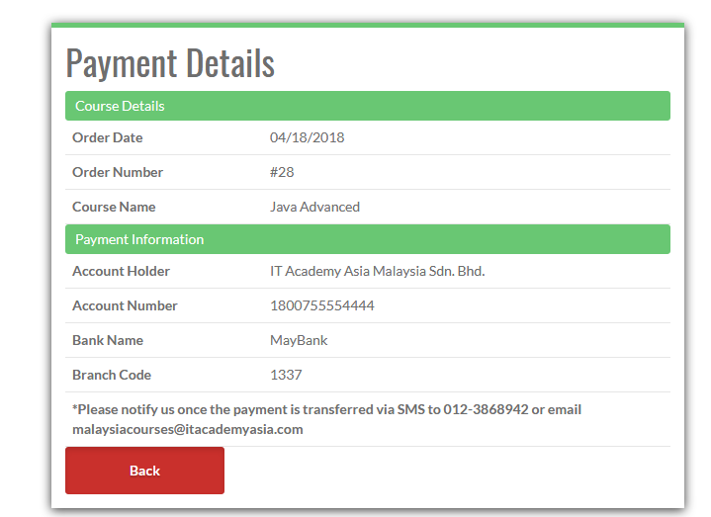

**Figure 1.6.1 View Request Page – Redirect to Pay Info Page**

After click ‘Pay Now’ button, it will redirect to this page to view the course details and payment information.

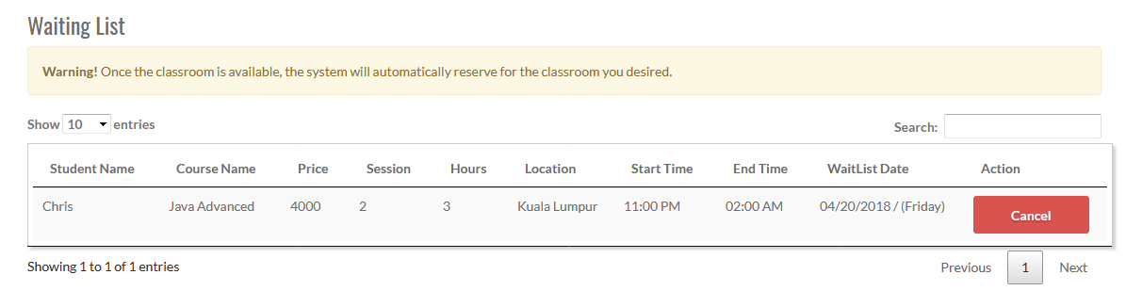

**Figure 1.7 View Waiting List Page**

If others student cancelled for a particular session, the system will automatically search for a new student who adds this particular session into waitlist early, then insert the new student into the particular session. However, it will not be displaying any data record with an expired session date.

1. Once student click ‘Cancel’ button, it will delete the wait list record from the database.

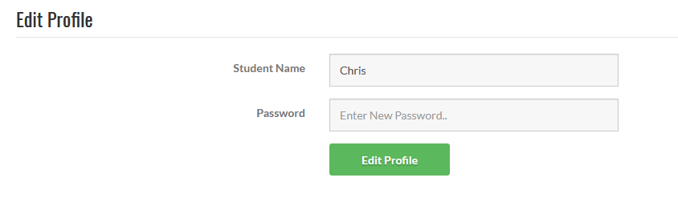

**Figure 1.8 Student Edit Profile Page**

Once student click ‘Edit’ button, it will update the user information. However, password input box is empty, which mean using back the previous password.

## 2.0 Lecturer Functionalities

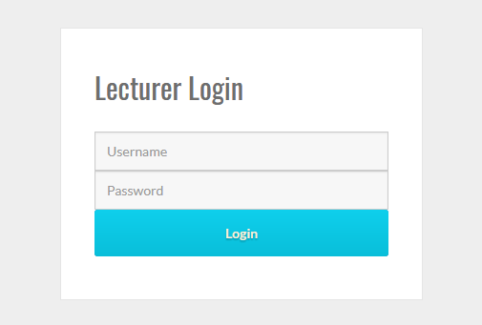

**Figure 2.0 Lecturer Login Page**

If lecturer inputted correct username and password, then it will successfully login to the system and redirect to view course page.



**Figure 2.0.1 Lecturer Login Page – Error Message**

If lecturer inputted incorrect username and password, then this error message will be displayed.

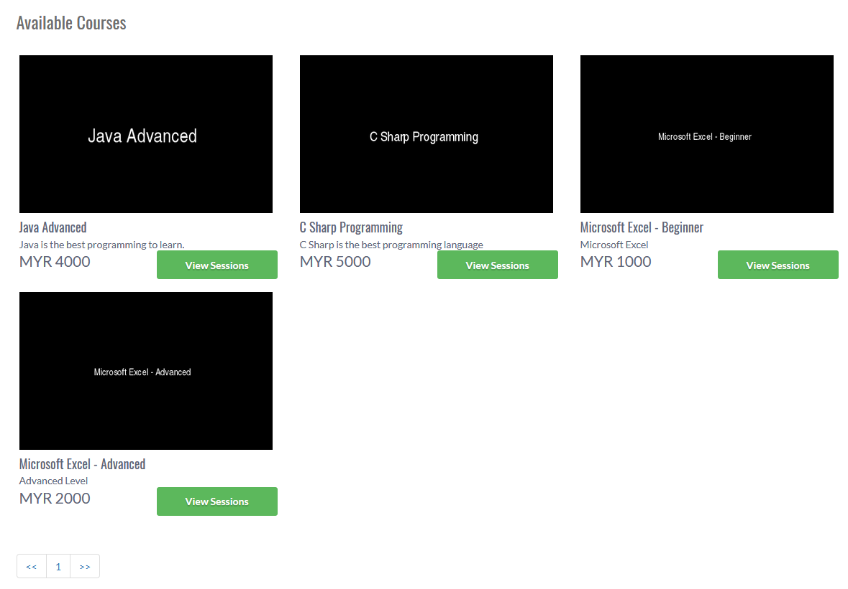

**Figure 2.1 View Course Page**

In this page, it will only display the course that is handled by the particular lecturer.

1. If lecturer wants to check available session from a particular course, click the ‘View Sessions’ button, it will redirect student to view session page.
2. However, there are only 6 courses in per page. If there are more than 6 courses, it will be more pages display. Therefore, if lecturer wants to view the second page, they can click the pagination.

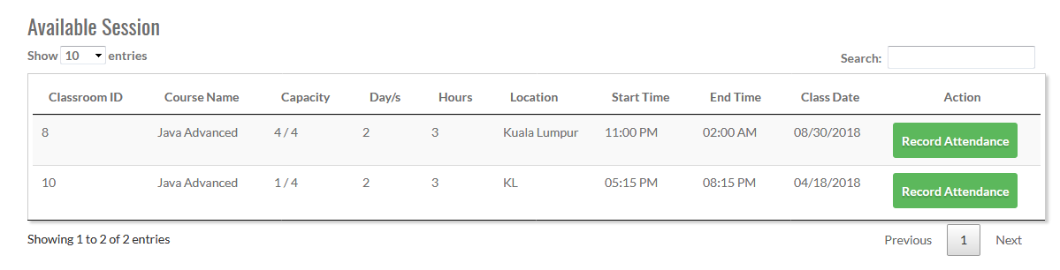

**Figure 2.2 View Session Page**

There are search and pagination function for this list view data. However, it will not be displaying any data record with an expired session date.

1. Once student click ‘Record Attendance’ button, it will pop up a dialog box to show how many sessions were in this particular course. Please refer to Figure 2.1.1 View Session Dialog Box.

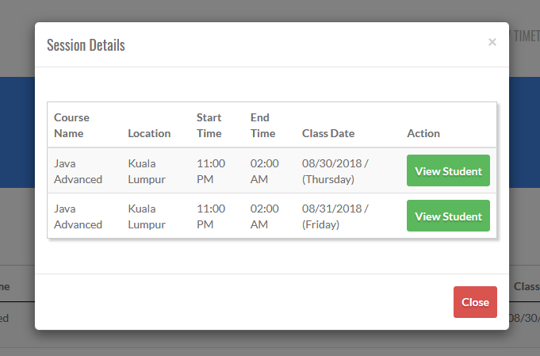

**Figure 2.2.1 View Session Page – View Session Dialog Box**

1. Click that cross icon to close the dialog box.
2. Click View Student button will redirect to attendance record page.
3. Click Close button will close the dialog box.

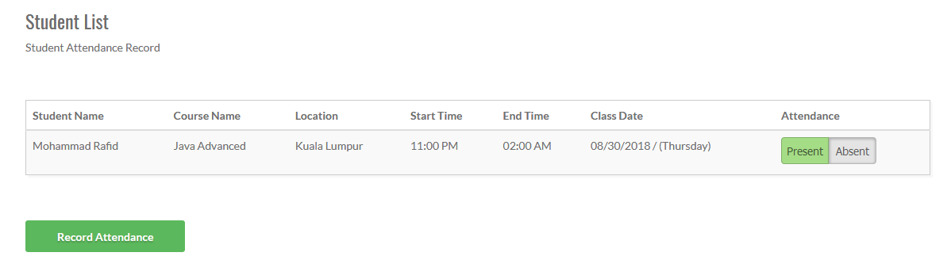

**Figure 2.3 Attendance Record Page**

1. Once student click ‘Record Attendance’ button, it will insert attendance record into the database.

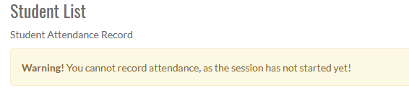

**Figure 2.3.1 Attendance Record Page – Error Message**

However, if the session has not started yet, the system will not allow a lecturer to make any attendance record.

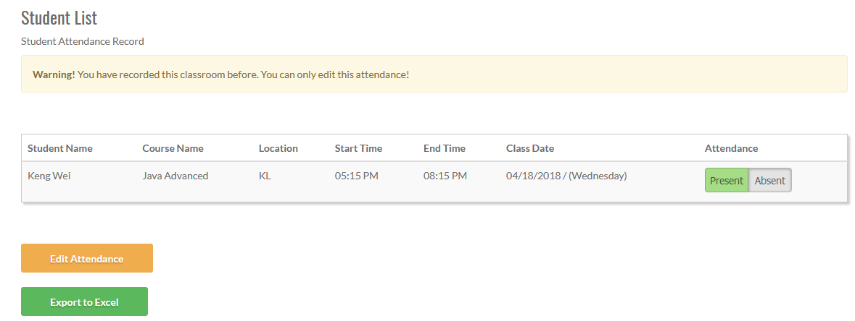**Figure 2.3.2 Attendance Record Page – Recorded Attendance**

Once the attendance has been recorded, then it only can be edit and download attendance record as excel file.

1. If click Edit Attendance button, it will just update the existed attendance record from the database.
2. If click Export to Excel button, it will export this attendance record into Excel file for the lecturer to download it.

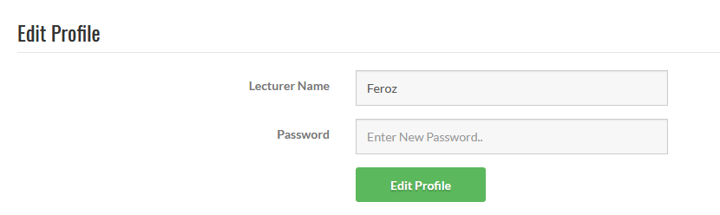

**Figure 2.4 Lecturer Edit Profile Page**

Once lecturer click ‘Edit Profile’ button, it will update the user information. However, password input box is empty, which mean using back the previous password.

## 3.0 Admin Functionalities

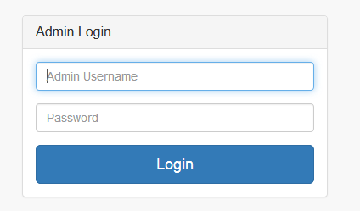

**Figure 3.0 Admin Login Page**

If admin inputted correct username and password, then it will successfully login to the system and redirect to dashboard page.

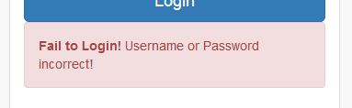

**Figure 3.0.1 Admin Login Page – Error Message**

If admin inputted incorrect username and password, then this error message will be displayed.

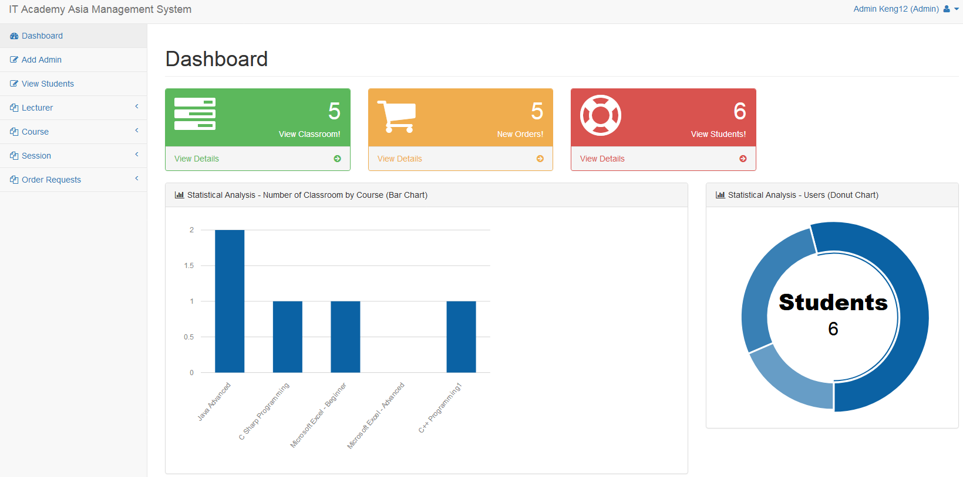

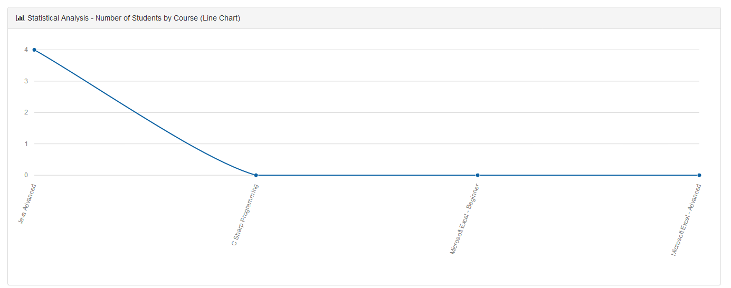

**Figure 3.0 Dashboard Page – Management System**

This is the Course Registration Management Page, in the content dashboard, it including the detailed information and 3 types of statistical analysis diagram, which are Bar Chart, Donut Chart and Line Chart.

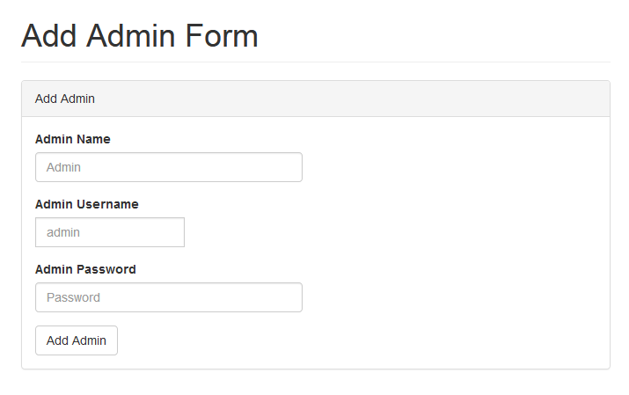**Figure 3.1 – Add Admin Page**

Admin must fill in all the information before click Add Coursebutton.

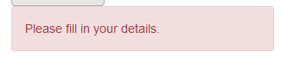

**Figure 3.1.1 – Admin Page – Error Message**

If the incorrect input was submitted, this error message will display.

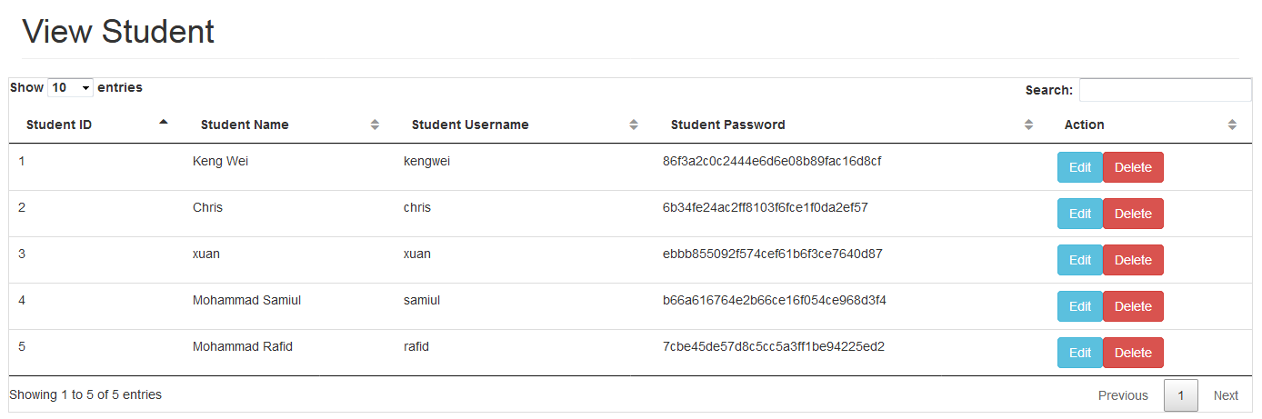

**Figure 3.2 View Student Page**

There are search and pagination function for this list view data. However, the student cannot be deleted if the student has reserved an active session in order to prevent some errors.

1. If admin click Edit button, it will redirect to edit page.
2. If admin click Delete button, it will delete for that particular record from the database.

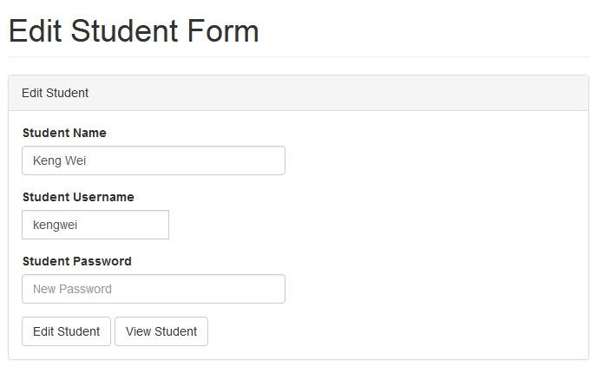

**Figure 3.2.1 - Edit Student Page**

1. If admin click Edit Student button, it will fetch the update query into the database.
2. If admin click View Student button, it will redirect back to the list view page.

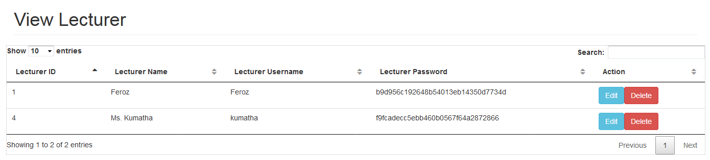

**Figure 3.3 View Lecturer Page**

There are search and pagination function for this list view data. However, the lecturer cannot be deleted if the lecturer is handling the course.

1. If admin click Edit button, it will redirect to edit page.
2. If admin click Delete button, it will delete for that particular record from the database.

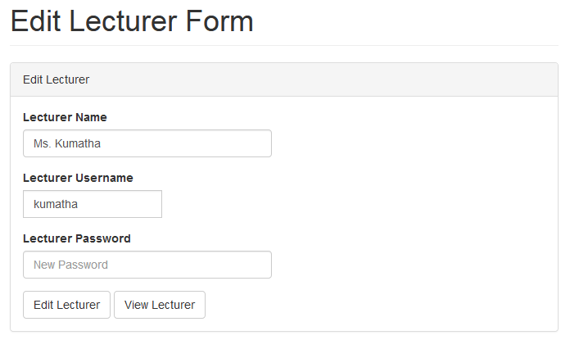

**Figure 3.3.1 - Edit Lecturer Page**

1. If admin click Edit Lecturerbutton, it will fetch the update query into the database.
2. If admin click View Lecturerbutton, it will redirect back to the list view page.

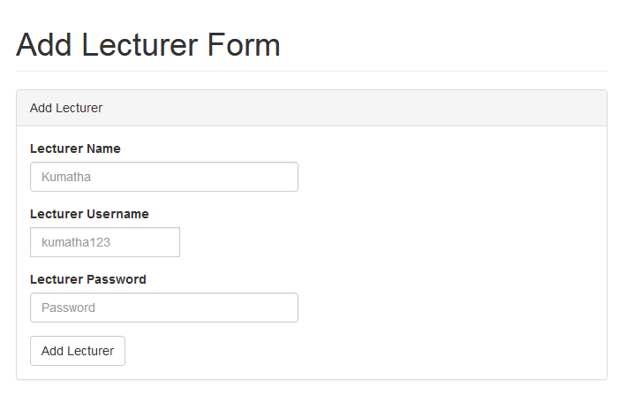

**Figure 3.3.2 – Add Lecturer Page**

Admin must fill in all the information before click Add Coursebutton.



**Figure 3.2.2.1 – Add Lecturer Page – Error Message**

If the incorrect input was submitted, this error message will display.

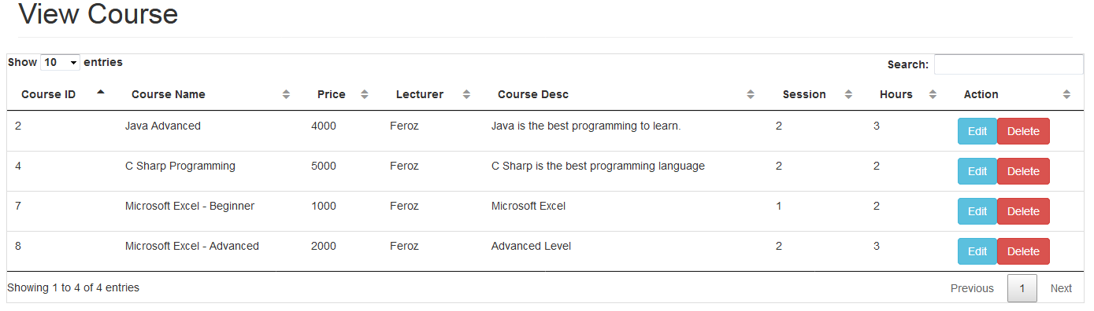

**Figure 3.4 View Course Page**

There are search and pagination function for this list view data.

1. If admin click Edit button, it will redirect to edit page.
2. If admin click Delete button, it will delete for that particular record from the database.

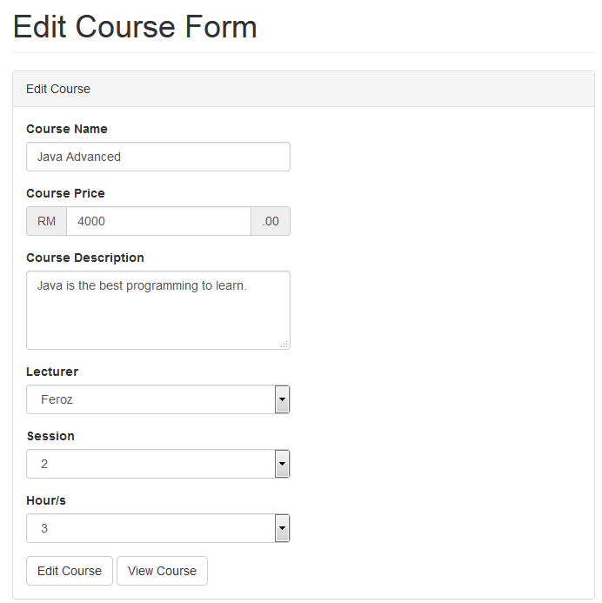

**Figure 3.4.1 - Edit Course Page**

1. If admin click Edit Coursebutton, it will fetch the update query into the database.
2. If admin click View Coursebutton, it will redirect back to the list view page.

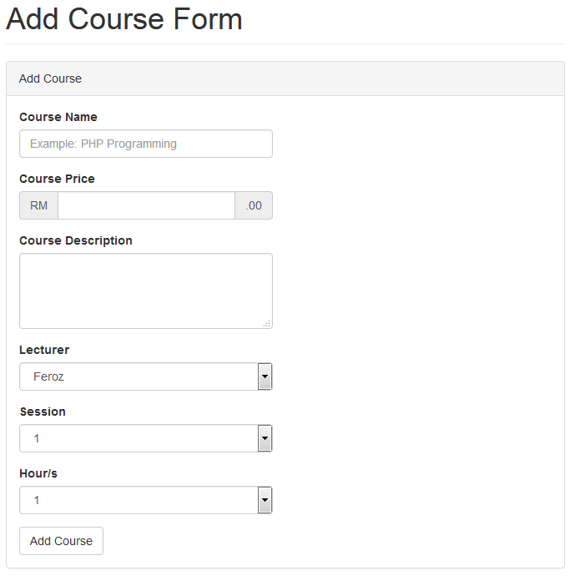

**Figure 3.4.2 – Add Course Page**

Admin must fill in all the information before click Add Coursebutton.



**Figure 3.4.2.1 – Add Course Page – Error Message**

If the incorrect input was submitted, this error message will display.

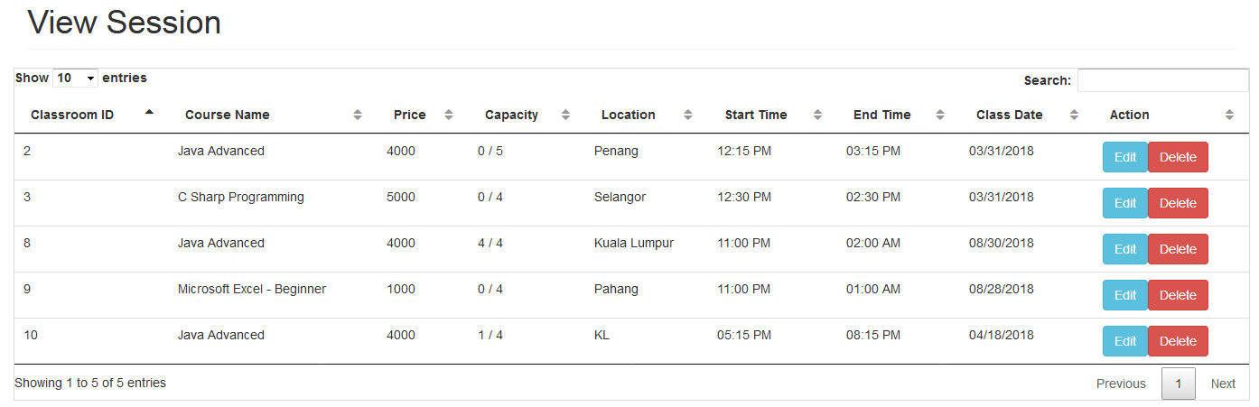

**Figure 3.5 View Session Page**

There are search and pagination function for this list view data. However, it will not be displaying any data record with an expired session date.

1. If admin click Edit button, it will redirect to edit page.
2. If admin click Delete button, it will delete for that particular record from the database.

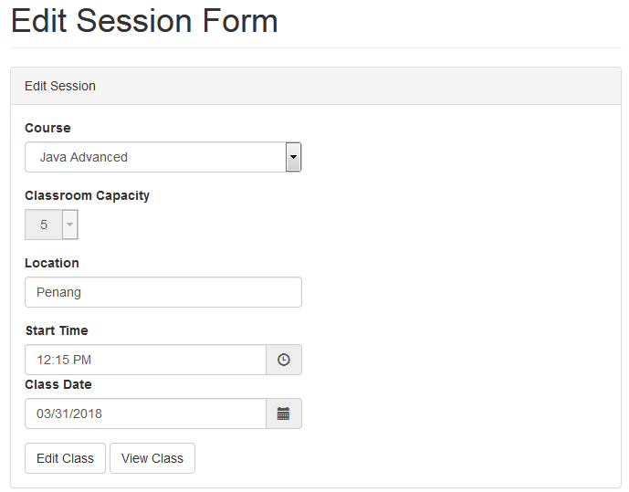

**Figure 3.5.1 - Edit Session Page**

1. If admin click Edit Sessionbutton, it will fetch the update query into the database.
2. If admin click View Sessionbutton, it will redirect back to the list view page.

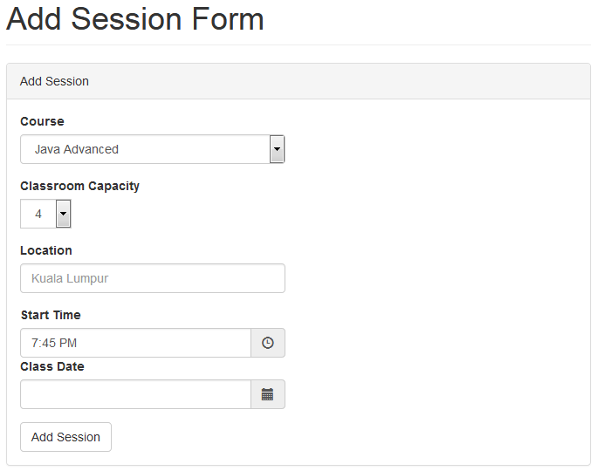**Figure 3.5.2 – Add Session Page**

Admin must fill in all the information before click Add Sessionbutton.



**Figure 3.5.2.1 – Add Session Page – Error Message**

If the incorrect input was submitted, this error message will display.

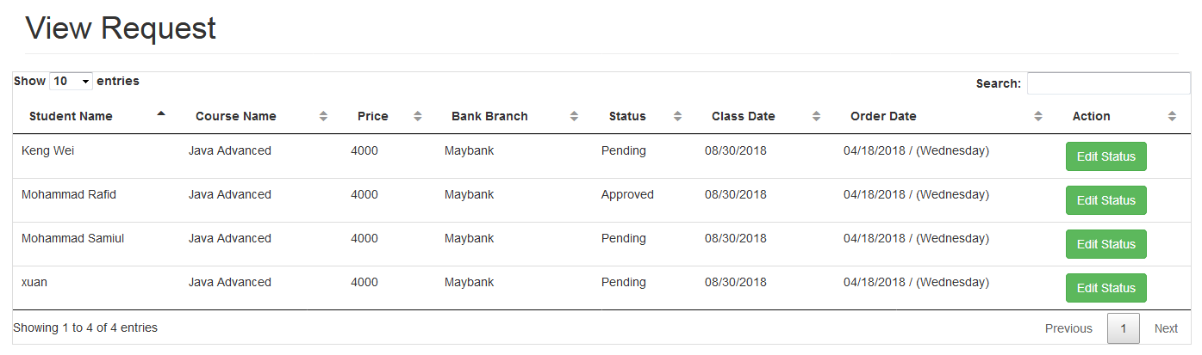

**Figure 3.6 View Session Page**

There are search and pagination function for this list view data. However, it will not be displaying any data record with an expired session date.

1. If admin click Edit button, it will redirect to edit page.

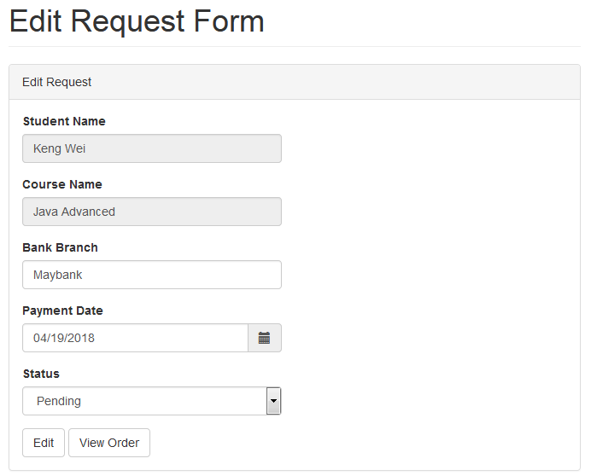

**Figure 3.6.1 - Edit Session Page**

1. If admin click Edit Requestbutton, it will fetch the update query into the database.
2. If admin click View Requestbutton, it will redirect back to the list view page.

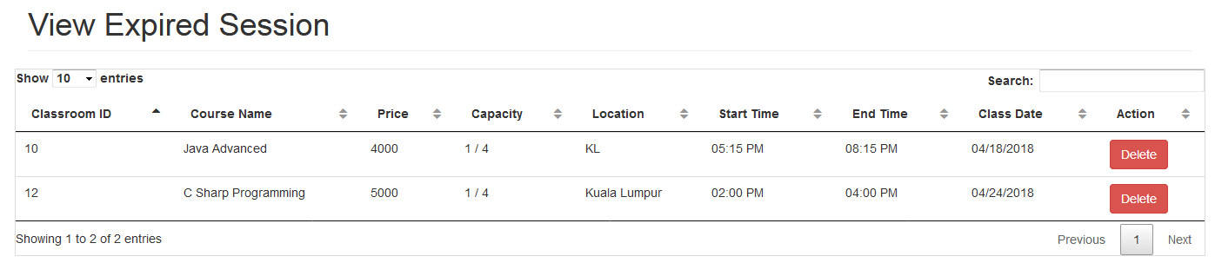

**Figure 3.7 – Expired Session**

This page is for admin to view the previous expired session. Furthermore, admin only can delete the session instead of editing it, as the session is already closed (Expired).

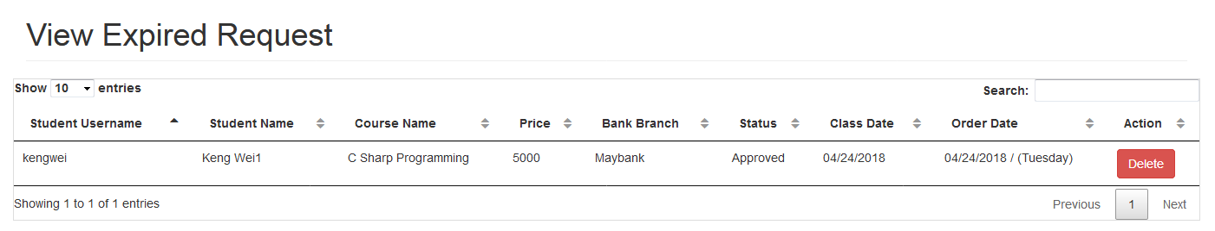

**Figure 3.8 – Expired Request**

This page is for admin to view the previous expired request. Furthermore, admin only can delete the request instead of editing it, as the request is already closed (Expired).

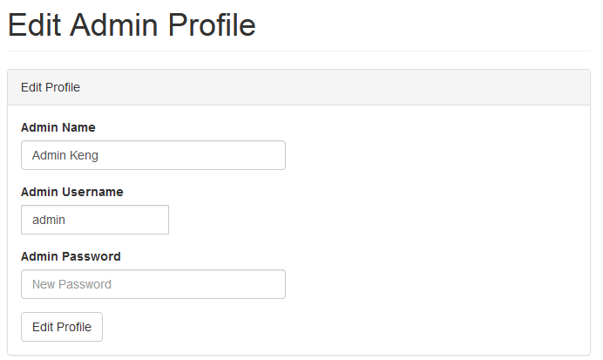

**Figure 3.9 – Edit Admin Profile Page**

Once admin click ‘Edit Profile’ button, it will update the user information. However, password input box is empty, which mean using back the previous password.

# Appendix D – Minutes of Meeting

**Minutes of Meeting – 1**

**Date:** 16 October 2017

**Student’s Name:** Teoh Keng Wei

|  |  |  |
| --- | --- | --- |
| **NO.** | **Issues** | **Discussion & Decision** |
| 1 | Proposal Background | Review background |
| 2 | Introduce the topic – Problem Statement | Review problem statement |
| 3 | Discuss Objectives | Review objectives |
| 4 |  |  |
| 5 |  |  |

**Supervisor’s Name:** Ms. Kumatha

**Minutes of Meeting – 2**

**Date:** 09 January 2018

**Student’s Name:** Teoh Keng Wei

|  |  |  |
| --- | --- | --- |
| **NO.** | **Issues** | **Discussion & Decision** |
| 1 | Chapter 1: Introduction | Show Introduction |
| 2 | Project: Problem Statement | Show problem statement |
| 3 | Project: Objectives | Show objectives |
| 4 |  |  |
| 5 |  |  |

**Supervisor’s Name:** Ms. Kumatha

**Minutes of Meeting – 3**

**Date:** 30 January 2018

**Student’s Name:** Teoh Keng Wei

|  |  |  |
| --- | --- | --- |
| **NO.** | **Issues** | **Discussion & Decision** |
| 1 | Chapter 2: Product Research | Show & Review Product Research |
| 2 | Chapter 2: Research of Similar Products | Show & Review Similar Products |
| 3 | Chapter 2: Course Registration Research | Show & Review Course Registration Research |
| 4 | Chapter 2: Tool and Software Research | Show & Review tool and software research |
| 5 |  |  |

**Supervisor’s Name:** Ms. Kumatha

**Minutes of Meeting – 4**

**Date:** 06 February 2018

**Student’s Name:** Teoh Keng Wei

|  |  |  |
| --- | --- | --- |
| **NO.** | **Issues** | **Discussion & Decision** |
| 1 | Chapter 3: Methodology Development | Show & Review Methodology Development |
| 2 | Chapter 3: Tools and Software used to develop a system | Show & Review Tools and Softwares |
| 3 | Chapter 3: Fact Finding | Show & Review Fact Finding |
| 4 | Chapter 3: Survey | Show & Review Survey |
| 5 |  |  |

**Supervisor’s Name:** Ms. Kumatha

**Minutes of Meeting – 5**

**Date:** 13 February 2018

**Student’s Name:** Teoh Keng Wei

|  |  |  |
| --- | --- | --- |
| **NO.** | **Issues** | **Discussion & Decision** |
| 1 | Chapter 4: Charts and Diagrams | Show & Review Charts and Diagrams |
| 2 | Chapter 4: Data Dictionary | Show & Review Data Dictionary |
| 3 | Chapter 4: User Interface Design | Show & Review User Interface Design |
| 4 |  |  |
| 5 |  |  |

**Supervisor’s Name:** Ms. Kumatha

**Minutes of Meeting – 6**

**Date:** 20 March 2018

**Student’s Name:** Teoh Keng Wei

|  |  |  |
| --- | --- | --- |
| **NO.** | **Issues** | **Discussion & Decision** |
| 1 | A prototype of Course Registration and Management System | Show the prototype system, but need some improvement |
| 2 | Chapter 5: Test Script Table | Show the Test Script Table |
| 3 |  |  |
| 4 |  |  |
| 5 |  |  |

**Supervisor’s Name:** Ms. Kumatha

**Minutes of Meeting – 7**

**Date:** 27 March 2018

**Student’s Name:** Teoh Keng Wei

|  |  |  |
| --- | --- | --- |
| **NO.** | **Issues** | **Discussion & Decision** |
| 1 | Chapter 6: Functionality Achievement | Show & Review Functionality Achievement |
| 2 | Chapter 6: System Modules and Functions | Show & Review System Modules and Functions |
| 3 | Chapter 6: Bugs and Input Validation | Show & Review Bugs and Input Validation |
| 4 | Chapter 6: User Manual | Show & Review User Manual |
| 5 | Chapter 6: Advantage and Disadvantage of Course Registration and Management System | Show & Review Advantage and Disadvantage of System |

**Supervisor’s Name:** Ms. Kumatha

**Minutes of Meeting – 8**

**Date:** 03 April 2018

**Student’s Name:** Teoh Keng Wei

|  |  |  |
| --- | --- | --- |
| **NO.** | **Issues** | **Discussion & Decision** |
| 1 | Chapter 7: Assessment of the final product | Show & Review Assessment of the final product |
| 2 | Chapter 7: Critically Access | Show & Review Critically Access |
| 3 | Chapter 7: Personal Experiences | Show & Review Personal Experiences |
| 4 | Chapter 7: Future Plan | Show & Review Future Plan |
| 5 |  |  |

**Supervisor’s Name:** Ms. Kumatha